**IS 601005 Web Systems Development**

**Final Report**

**AIM**

**Assignment Information Management**

**Professor: Thomas Licciardello**

**Team Name: Aces**

Anshul Shivhare (as4432)

Indudhar Sitaram Adi Moole (is397)

Narella Vamshi (nv345)

Karan Chitroda (ksc42)

Baba Avinash Puppala (bp479)

**Table of Contents**

**Phase 1**

1. Project Summary
   * Key Features
   * Benefits
   * Overall Impact
2. The System Setting
3. Describe the Project Environment
   * Impact of the System
   * System Users and Functional Responsibilities
4. The Systems Description
5. Goals of the System
6. Data Gathering Plan

**Phase 2**

1. Summary
2. Data Flow Diagrams
   * Level 0 Diagram
   * Level 1 Diagrams
     + Student and Professor Interaction
     + Analytics and Reporting
     + User Management
     + Feedback System
   * Level 2 Diagrams
     + Student
     + Professor
     + Feedback Generation
     + Report Generation
3. Menu Hierarchies Application
4. Report Design

**Phase 3**

1. Project Analysis:
   * Project Cost Estimation
   * Resource Allocation
     + Development Team
     + QA Team
     + Project Management
     + Resource Requirements
     + Project Timeline
2. Systems Analysis – Use Case diagram.
   * Use Case Diagram Processes
3. Major Processes, Decision Tables, and Decision Tree
   * Explanation of Major Processes
   * Decision Tables
   * Decision Trees
4. Database Design and Schema Diagrams

**Phase 4**

1. Demo PPT
2. Application Screenshots
3. Navigation around the Application
4. User Input Transactions
5. Modifying the Submitted Assignment
6. Report Results

**Phase 5: System Implementation**

1. Architecture Diagram
2. Application Testing
   * Testing Key Features
   * Bugs Encountered
3. Application Training
4. Implementation Plan
   * Deployment Stack
   * Rollout Phases
   * Agile Workflow
5. Support Plan
6. Future Modification

**Appendix**

1. Project Approval Form
2. Gantt Chart
3. Meeting Logs
4. Variance Report

**Phase I**

**A. Project Summary**

**Assignment Information Management (AIM) System**

The AIM System is a cutting-edge web-based application designed to revolutionize the assignment submission and review process within academic institutions. Tailored for both students and professors, this platform addresses key pain points and enhances overall efficiency in managing assignments.

**Key Features:**

**User Roles**: The AIM System caters to two primary user roles—Students and Professors—ensuring a seamless experience for both stakeholders.

**Student Impact:** For students, the platform offers unparalleled convenience through online submission and effective deadline management. By streamlining the assignment process, students benefit from a more straightforward and accessible workflow.

**Professor Impact:** Professors, on the other hand, experience a significant impact on efficiency. The system facilitates the creation, grading, and feedback processes for assignments, fostering improved communication and transparency. Additionally, professors can leverage analytics and reporting tools to gain valuable insights into student performance.

**Benefits:**

**Paperwork Reduction:** The AIM System significantly reduces the reliance on traditional paperwork, contributing to a more sustainable and eco-friendlier academic environment.

**Enhanced Accessibility:** With online submission and streamlined processes, the platform enhances accessibility for both students and professors, promoting a more inclusive academic experience.

**Workflow Efficiency:** By optimizing assignment-related tasks, the AIM System improves workflow efficiency, allowing academic institutions to allocate resources more effectively and focus on delivering a higher quality of education.

**Overall Impact:**

The AIM System not only modernizes the assignment management landscape but also elevates the academic experience for all stakeholders. From students enjoying the convenience of online submissions to professors benefiting from streamlined grading processes and insightful analytics, the platform sets a new standard for assignment information management. Embracing the AIM System leads to a reduction in administrative burdens, improved communication, and ultimately enhances the overall educational journey.

**B. System Settings**

The AIM System is designed for implementation within academic institutions, serving the needs of both students and professors. It is not industry-specific but rather tailored to optimize the assignment submission and reviewing process in an educational setting.

**C. Describe the Project Environment**

The system described, the Assignment Information Management (AIM) System, is presented as a concept or proposal for a new system. There is no information provided about its current state or effectiveness. Let's outline the potential impact it could bring.

**Impact of the AIM System:**

**Efficient Assignment Management:**

The AIM System aims to streamline the process of creating, submitting, and reviewing assignments for both professors and students. This efficiency can lead to time savings and a more organized workflow.

**Enhanced Communication:**

The platform facilitates communication between professors and students regarding assignments. Clear instructions, submission status, and feedback can contribute to a more effective learning environment.

**Performance Tracking:**

Professors can track the performance of students over time, allowing for better insights into individual and class-wide achievements. This can aid in identifying areas for improvement or recognizing outstanding performance.

**Centralized Information:**

All assignment-related information is centralized in one system, reducing the likelihood of miscommunication or lost data. This can contribute to a more reliable and accessible information repository.

**Data-Driven Decision Making:**

The system's ability to generate reports provides administrators and professors with valuable insights into student performance trends, helping them make informed decisions to enhance the overall educational experience.

**User Accountability**:

The system introduces a structured approach to assignment submission and grading, fostering a sense of accountability among students and professors. Clear timelines and feedback contribute to a more transparent evaluation process.

**User-Friendly Interface:**

A well-designed user interface ensures that both professors and students can easily navigate and interact with the system. This can contribute to user satisfaction and the overall success of the system.

**Adaptability and Scalability:**

If designed with scalability in mind, the system can adapt to the changing needs of educational institutions. Additional features or modifications can be implemented to accommodate growth or evolving requirements.

It's important to note that the actual impact and effectiveness of the AIM System would depend on various factors, including the implementation, user adoption, and ongoing system management. Additionally, feedback from users during and after implementation would be crucial to refining and optimizing the system for maximum benefit.

**System Users and Functional Responsibilities**

Academic institutions form the core of the AIM (Assignment Information Management System) project environment, which optimizes the ecology for handling assignments. Important elements of the project setting consist of:

1. **Educational Institutions**: The system is designed to be implemented in a variety of educational settings, including colleges, universities, and schools, regardless of the subjects they teach.
2. **Web-Based Platform**: The AIM System is a web-based program that facilitates device accessibility and guarantees users may interact with it without difficulty on desktop, laptop, or mobile devices.
3. **User Roles**: The project involves two primary user roles—Students and Professors—each with distinct functionalities tailored to their needs within the academic context.
4. **Technical Infrastructure**: The system runs on a technology platform that facilitates data analytics, grading features, and safe online submissions. Databases, cloud services, and other technological elements might be used to provide scalability and dependability.
5. **Communication**: Professors and students work together and communicate more when using the AIM System. This improves communication among members of the academic community overall and includes tools for submitting, grading, and providing comments on assignments.
6. **Scalability**: The size and structure of academic institutions might range greatly, so the project environment is made to be scalable to meet the various demands of various learning environments.
7. **Feedback** **Mechanism**: The system has feedback mechanisms built in to collect user inputs, allowing for ongoing refinement and enhancement in response to changing needs from academic stakeholders.

**D. The Systems Description**

**A. Principal Inputs for Users and Admins:**

**Users:**

**1. Students:**

* Assignment details (title, description, submission date).
* File attachments for assignment submissions(.zip format only).
* Feedback forms or comments from professors.

**2.Professors/Admins:**

* Assignment creation details (title, instructions, grading criteria).
* Student submissions for grading.
* Feedback and grades for students.
* Analytics preferences and parameters.

**B. Process to Handle Data:**

**1. Database:**

* The AIM System uses a relational database to store information such as user profiles, assignment details, submissions, grades and other system configurations.
* Database management system (DBMS) is employed to ensure efficient storage, retrieval, and manipulation of data. And also to process the CRUD operations smoothly.

**2. User Interface:**

* The system provides a user-friendly web-based interface accessible to both students, professors and admin.
* Students can submit assignments, view the deadlines and access feedback.
* Professors can create assignments, evaluate submissions, and provide feedback through an aesthetic interface.

**3. Data Entry:**

* Students input assignment details and upload files through a submission form. For this project we have limited the format to .zip only.
* Professors create assignments, enter grading criteria, and provide feedback through dedicated interfaces.
* Admin can configure system settings and user roles in the system.

**C. Outputs:**

**1. Database Updates:**

* The database is updated in real-time with new assignment details, submissions, grades, and feedback.
* System configurations and user profiles are updated when the admin makes changes.

**2. Reports:**

* The system generates customizable reports for administrators, providing insights into system usage, user activity, and performance metrics.
* Professors can access reports on student performance, submission trends, and grade distributions.

**3. Communication:**

* Automated notifications are sent to students for assignment deadlines, submission confirmations, and feedback availability. The notifications are sent based on a time frame.

**4. Exports:**

* Professors can export grade sheets and performance reports in various formats (CSV, Excel) for further analysis or records.
* Backup and export functionalities are in place for administrators to ensure data integrity and consistency.

**5. Integrations:**

* The system may integrate with other academic platforms or tools for information exchange.
* Integration with learning management systems (LMS) or institutional databases may be considered for a holistic academic environment.

By specifying these components, the Systems Description describes how data moves through the AIM System, from user inputs via database operations to a range of outputs that help with academic administration and assignment management.

**E. Goals of the System**

* 1. **Boost Students' Assignment Submission Efficiency**: The intention is to make the process of students turning in assignments more efficient and straightforward. This entails developing an easy-to-use interface that makes it possible for students to turn in assignments without difficulty. An easy and stress-free submission process is enhanced by features including file uploads, submission status tracking, and deadline notifications.
  2. **Improve Grading accuracy and speed**: This objective is to make instructors' grading processes as efficient as possible. The accuracy and efficiency of grading assignments can be improved by including features like bulk grading capabilities, inline commenting, and automatic grading rubrics. By lessening their administrative workload, educators will be able to give timely and helpful comments.
  3. **Timely** **Feedback**: The goal of the system is to create an encouraging feedback loop between instructors and students. A more dynamic and responsive connection is made possible by features like quick feedback delivery, and a centralized communication platform. This objective encourages ongoing feedback and participation, which enhances the learning process.
  4. **Accessibility**: The system aims to be usable on a range of platforms, such as mobile, laptop, and desktop computers. This objective encourages flexibility and usability in a variety of academic contexts by guaranteeing that instructors and students can interact with the platform whenever it is convenient for them.
  5. **Reduce** **Paperwork**: Reducing the amount of traditional paperwork and the administrative burden related to assignment management are the main objectives. The system provides a digital platform for submission, marking, and record-keeping, making the academic environment more resource-efficient and sustainable.

**F. Data Gathering Plan:**

**1. Requirements Gathering:**

* Organize meetings with academic staff, including professors, teaching assistants, and admin to understand their current workflows in assignment creation, submission, grading, and feedback.
* Use these sessions to identify pain points, challenges, and areas where the existing process could be streamlined or improved.
* The sessions can be conducted either in person or virtually.

**2. Surveys:**

* Develop and distribute surveys to both students and professors to collect quantitative data on their satisfaction levels with the current assignment management system.
* Ask them about certain elements that they find useful, about places that they find difficult, and about any ideas they may have for changes.

**3. Employee Interviews:**

* Conduct one-on-one interviews with key stakeholders, such as professors who heavily engage with assignment management.
* Using it to gather in-depth insights into their experiences, preferences, and any specific issues they encounter in their roles.

**4. User Workshops:**

* Facilitate user workshops with a mix of students and professors to encourage open discussions about their expectations from an ideal assignment management system.
* Utilize collaborative activities and brainstorming sessions to uncover potential features and functionalities that may not be immediately apparent.

**6. Documentation Review:**

* Review existing documentation related to the current assignment management system, including user manuals, help guides, and any documented issues or feedback.

**7. User Observation:**

* Observe students and professors interacting with the existing system to identify any pain points or inefficiencies in real-time.
* Document common user workflows and tasks to ensure that the new system or upgrades address the actual needs of users.

Through the use of these techniques for obtaining data, we are able to design the AIM System that genuinely fulfills the needs of its users by gaining important insights into the particular demands and expectations of both instructors and students.

**Phase II**

**A. Summary**

Assignment Information Management (AIM) is a comprehensive platform designed to streamline and enhance the assignment management process within educational institutions. The system encompasses a range of features and functions tailored to the needs of students, professors, and administrators.

**Key Features and Functions of AIM:**

**User Roles:**

AIM supports two key user roles: students and professors, with adapted functionalities to fulfill their unique requirements.

**Login and Registration**

Users, both students, and professors, have secure and personalized access through a login system. Also new students and professors can easily be registered as new users.

**Admin Reports**

Admin has rights to access some reports to better understand the assignment submissions from the students. Admin will also have right delete or edit existing users in the application

**Online Submission:**

Students can conveniently submit assignments and projects online, eliminating the need for physical paperwork.

**Assignment Creation:**

Professors can effortlessly create assignments with detailed instructions, due dates, and necessary attachments.

**Grading and Feedback:**

Professors can efficiently evaluate student submissions and provide feedback directly through the platform.

**Paperwork Reduction:**

AIM significantly reduces paperwork associated with assignment management, contributing to a more sustainable and environmentally friendly academic environment.

**Improved Academic Experience:**

The overall design of AIM aims to enhance the academic experience for all stakeholders by combining convenience, transparency, and efficiency.

**Transparency and Accessibility:**

AIM promotes transparency by providing access to assignment details, guidelines, and supplementary materials, fostering better understanding among students.

**B. Data Flow Diagrams**

Data Flow Diagrams (DFDs) are graphical representations that illustrate the flow of data within a system and the processes that transform that data. DFDs are commonly used in systems analysis and design to model the functional aspects of a system.

**Level 0 Diagram**

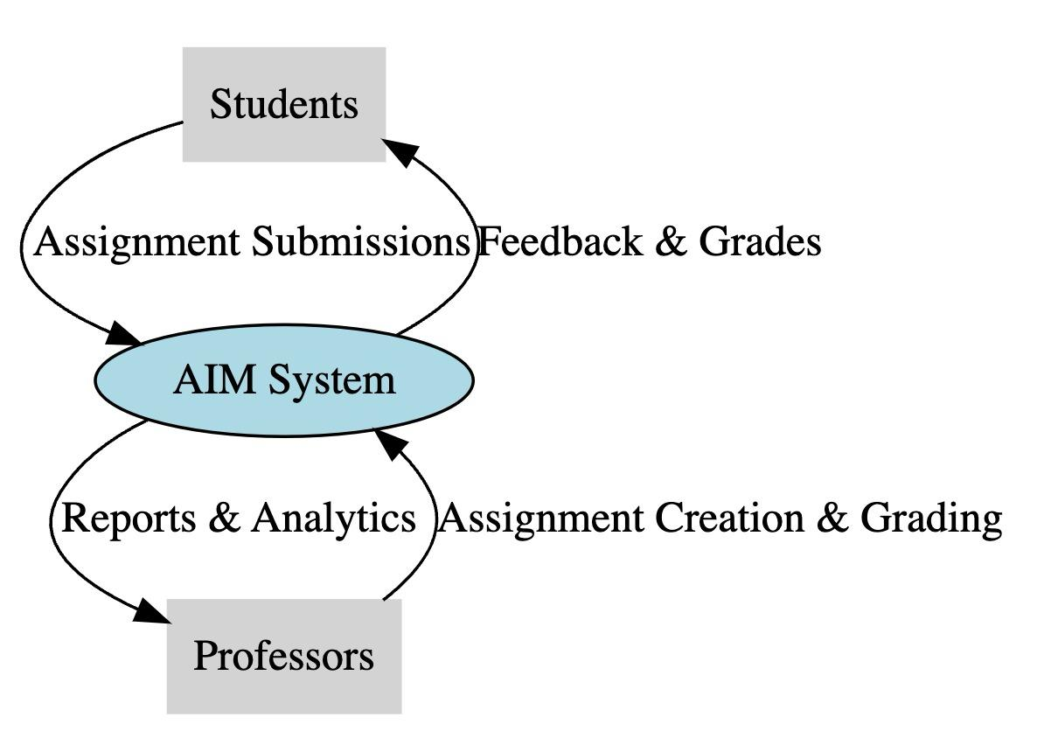

**Entities**:

* **Students**: Users who interact with the system to submit assignments and manage deadlines.
* **Professors**: Users who create assignments, grade submissions, and communicate with students.
* **Database**: The repository of assignment data, user information, and system records.

Processes:

* **Submit Assignment**: The process of students submitting assignments online.
* **Create/Grade Assignment:** The process of professors creating assignments, grading submissions, and providing feedback.
* **Communication**: The process of communication between professors and students through announcements and updates.
* **Data Storage**: Interaction with the database for storing and retrieving assignment-related data.

**Level 1 Diagrams**

**Student and Professor Interaction**

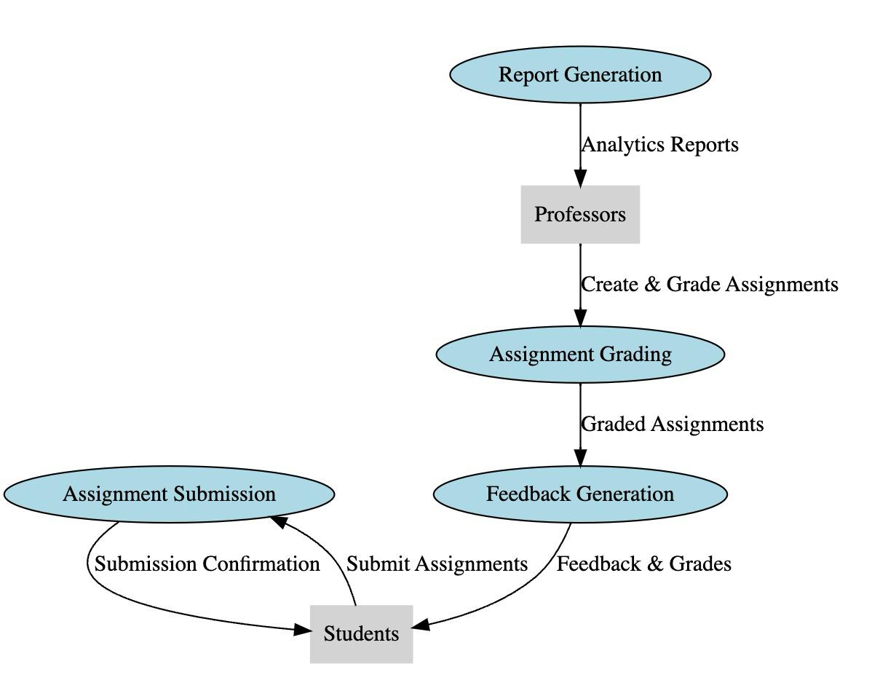

**Analytics and Reporting**

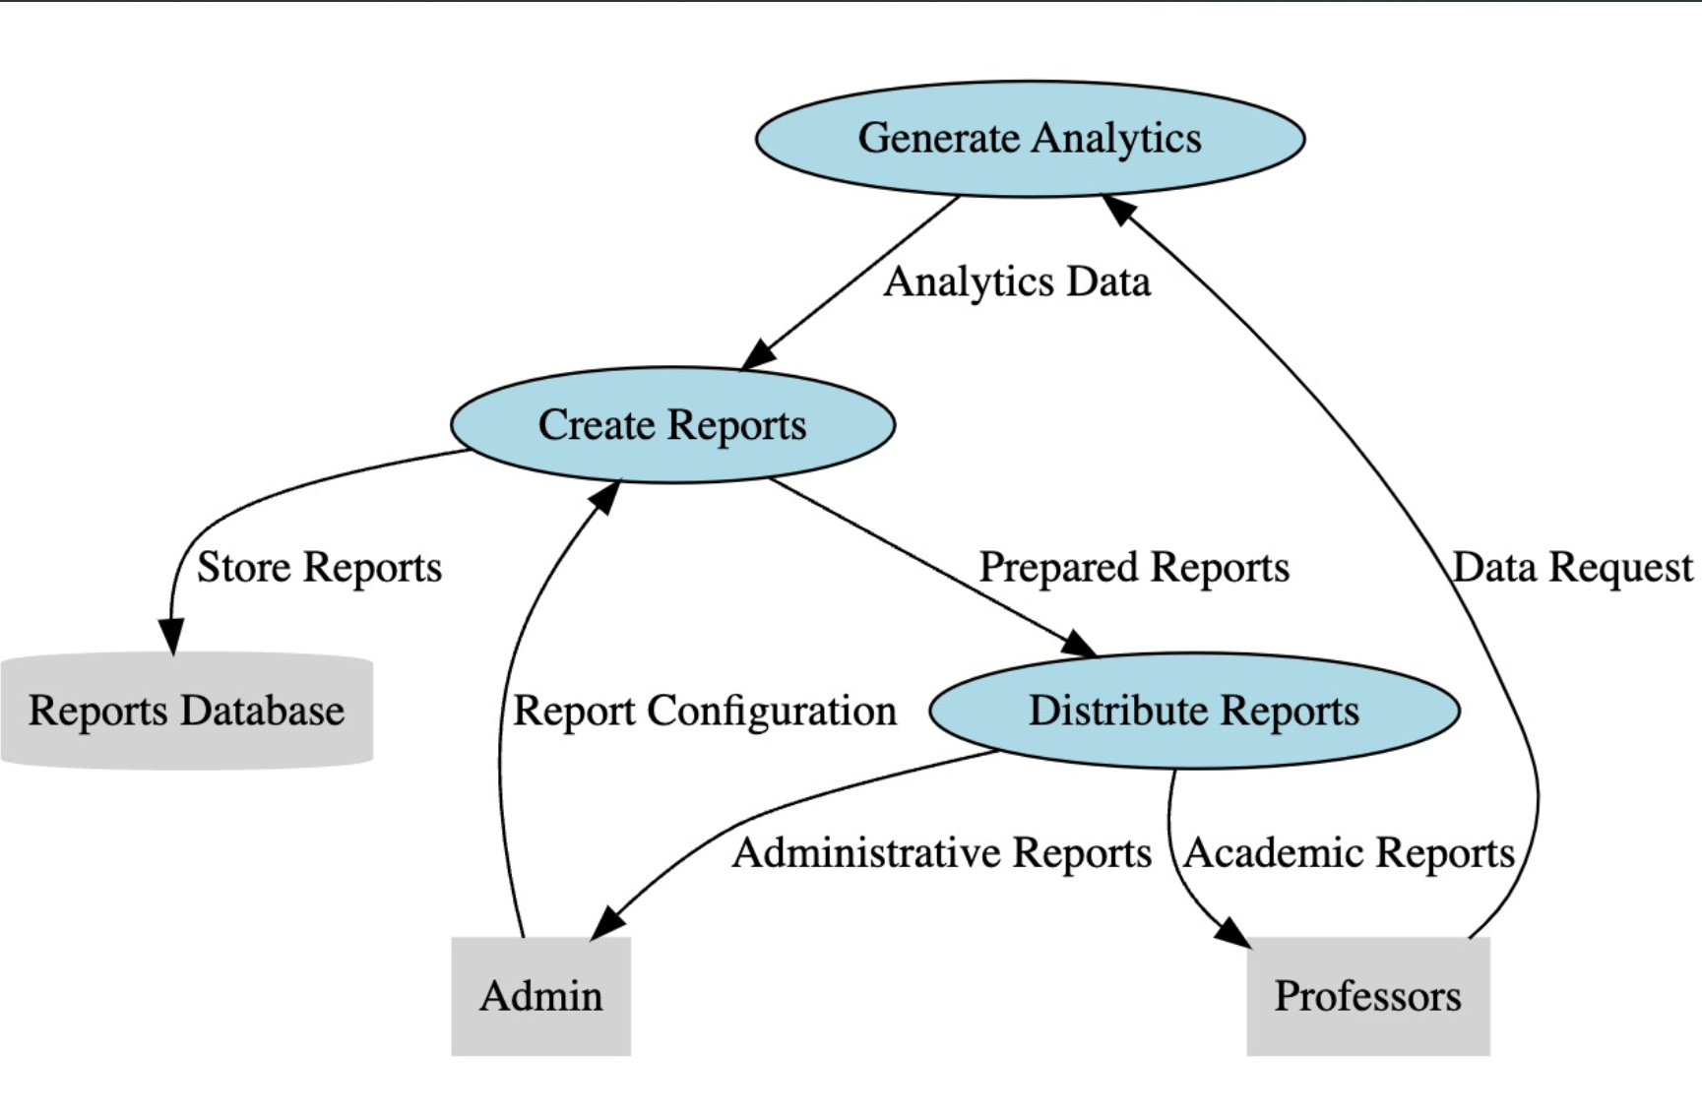

**User Management**

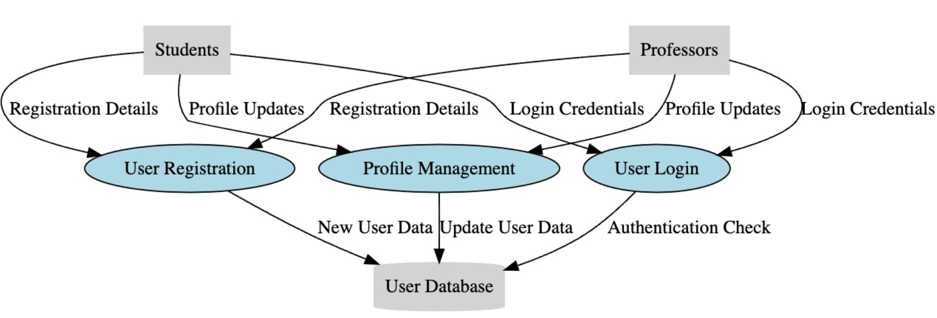

**Feedback System**

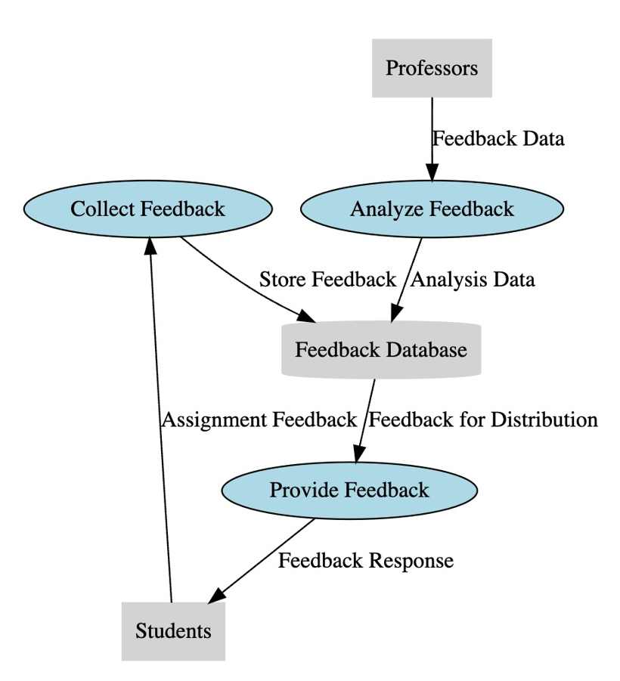

**Level 2 Diagrams**

**Student**

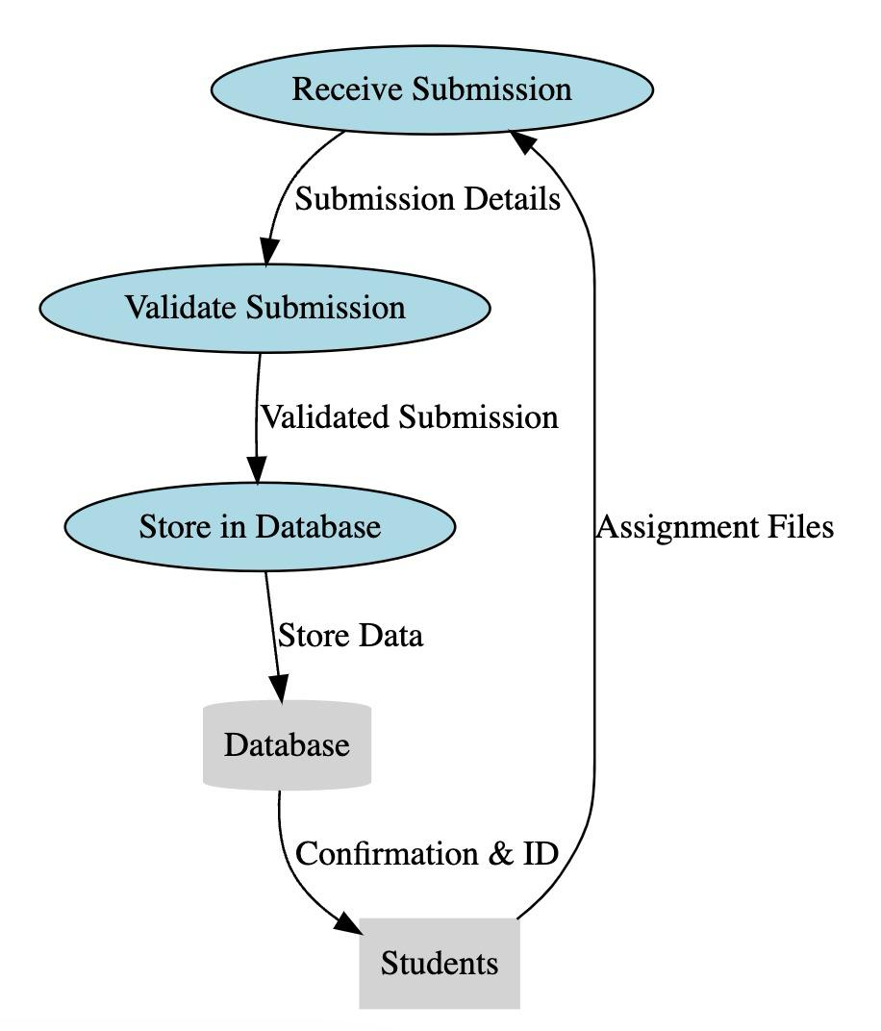

**Professor**

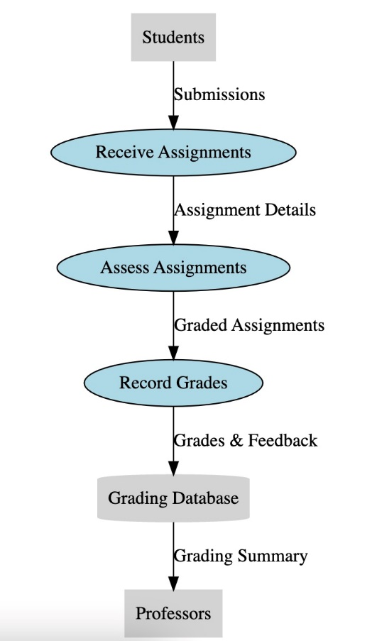

**Assignment Grading**

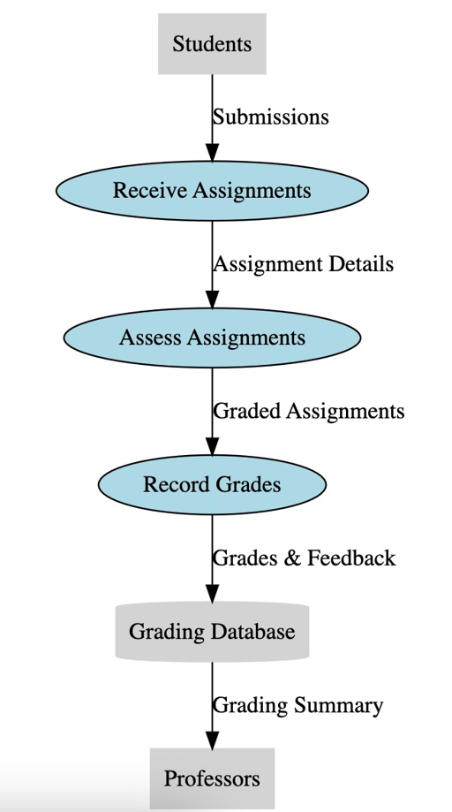

**Feedback Generation**

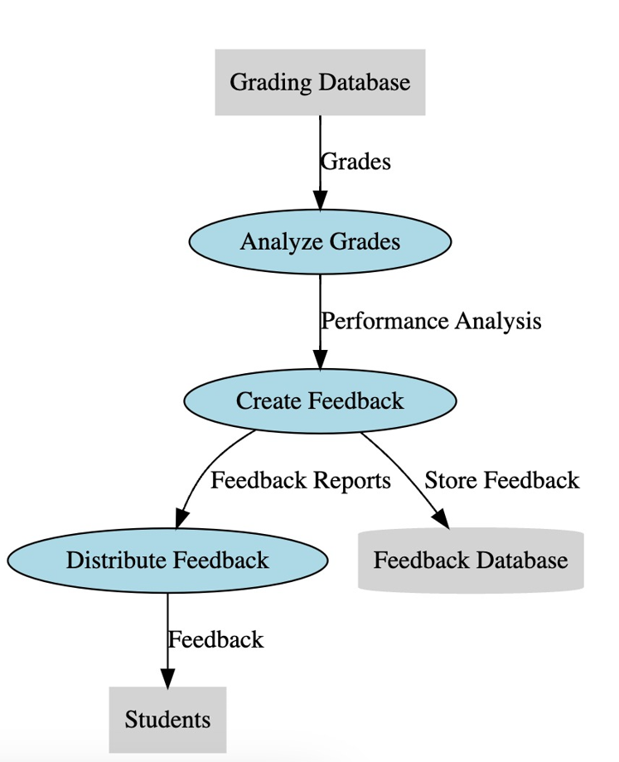

**Report Generation**

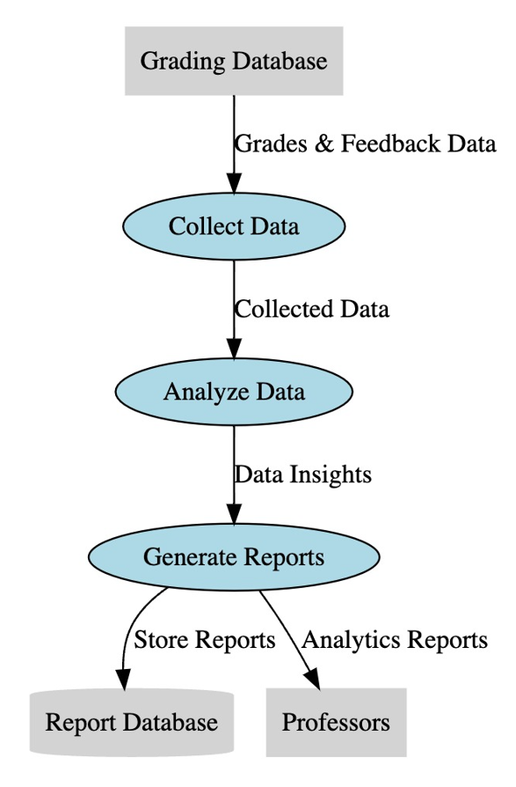

**C. Menu Hierarchies Application**

**Student**

* **Home**: Home navigates the user to the search assignment screen.
* **Search Assignment**: This screen is used to search for an assignment using the token provided by the professor.
* **View History**: This screen will show all the assignment submissions for the student. In this screen students can review the gradings as well.
* **Profile**: This screen shows the student profile details present in the system.
* **Logout**: This Menu Item can be used to logout from the system.

**Professor**

* **Home**: Home navigates the user to the add assignment screen.
* **Add Assignment**: This screen is used by the user to add an assignment into the system. This screen also generates the token value for the students.
* **View and Review Assignment**: This screen has all the assignments submitted by the professor. This screen also shows the submissions by the students and allows the professor to grade these assignments.
* **Profile**: This screen shows the professor profile details present in the system.
* **Logout**: This Menu Item can be used to logout from the system.

**Admin**

* **Home**: Home screen has all the reports currently available for the admin to see. Admin can choose the report as per their preference.
* **Logout**: This Menu Item can be used to logout from the system.

**D. Report Design**

**List of Students who score the highest in a particular project:**

**Purpose:**

This report aims to identify and acknowledge students who excel in a specific project. It provides a quick overview of the highest achievers, recognizing their academic performance.

**Parameters:**

The report requires the input of the project name or ID for which the highest scores are to be identified.

**Data Flow:**

* Administrators input the project details.
* The system selects data from the Analytics Database, identifying students with the highest scores.
* The report is generated, listing students and their respective scores for the specified project.

**Use Case:**

Faculty and administrators can use this report to recognize outstanding students, potentially for awards or special mentions.

**Sample Layout**

Template

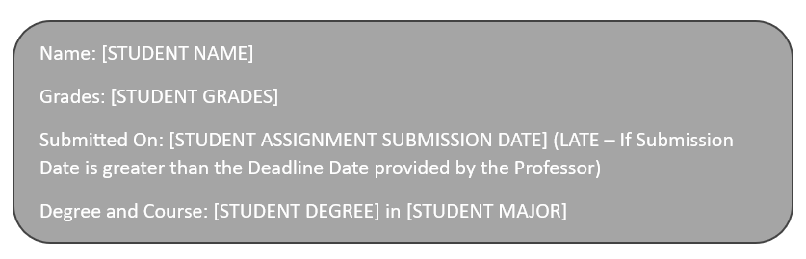

Application Screenshot

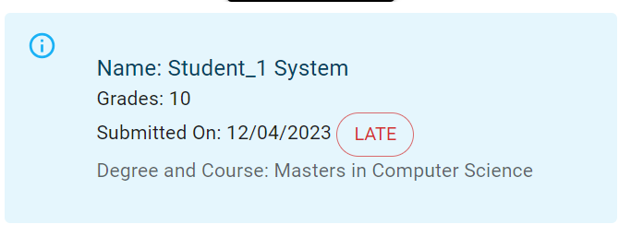

**List of Students who score the highest in each project a particular Professor has submitted:**

**Purpose**:

This report provides insights into the performance of students across projects submitted by a specific professor. It helps assess the impact of a professor's teaching and project assignments on student outcomes.

**Parameters**:

The report requires the input of the professor's name or ID for whom the highest scoring students are to be identified across all projects.

**Data Flow:**

* Administrators input the professor's details.
* The system selects data from the Analytics Database, identifying students with the highest scores in each project submitted by the specified professor.
* The report is generated, listing students, their respective project names, and scores.

**Use Case:**

Academic departments and administrators can use this report for performance evaluations and to assess the effectiveness of a professor's teaching methods.

**Sample Layout**

Template

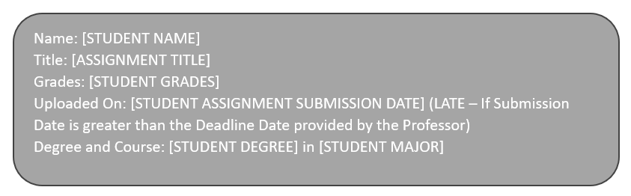

Application Screenshot

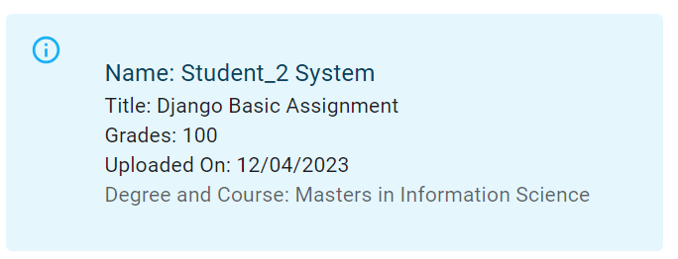

**List of Students who submitted the Assignment after the deadline:**

**Purpose**:

This report is designed to identify students who submitted assignments after the specified deadline. It helps enforce deadlines and ensures accountability for timely submissions.

**Parameters**:

The report requires the input of the assignment name or ID and the deadline against which late submissions are to be identified.

**Data Flow:**

Administrators input the assignment details and deadline.

The system selects data from the Submission Database, identifying students who submitted the assignment after the specified deadline.

The report is generated, listing students and the details of the late-submitted assignments.

**Use Case:**

Faculty and administrators can use this report to address issues related to late submissions, implement appropriate penalties, and maintain fairness in the assessment process.

**Sample Layout**

Template



Application Screenshot

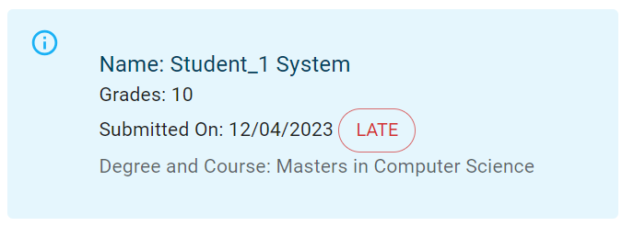

**Phase III**

**A. Project Analysis**

**Project Cost Estimation**

1. **Hardware**

Since the AIM System is a web-based application, the hardware requirements are relatively low (because it has been built as a small-scale project for the coursework). Hence, the laptop/PC/workstation can itself act as the server(localhost) and client as well. A robust server infrastructure may be required if the project is deployed on a large scale in future. As of now, the users and the vendors will get a smooth and aesthetic experience.

We plan to go to AWS Suite to deploy the Application in Future.

* AWS EC2 Prizing: Average as low as 10$/Month. Making use of Free Tier Options.

1. **Software**

The Software includes many system attributes such as Development tools, Database systems, and Web hosting services. These all services are a big necessity for a web development process. Licensing fees for certain software components may apply.

* IntelliJ IDEs: 77.9$ Monthly

(https://www.jetbrains.com/idea/buy/?section=commercial&billing=monthly)

* MongoDB: 0.10$ / Million Reads

(https://www.mongodb.com/pricing)

1. **Labor**

This project at this level only requires developers and a project manager. Since this is part of course work, no labor cost is involved. But in future the application might require paid team of developers, designers and managers, for which the cost can not be predicted as of now. We have added the expense considering the average market value.

* Developer: 30$/Hour
* Project Manager 40$/Hour

1. **Other Expenses**

There are some other required funds as well that are very important for sustainable development of the application. The exact amount of these categories depends on the scale of application. Considering an average sized application, we have added the expenses.

* Testing Expenses: 30$/Hour per Tester
* Contingency Funds(Some buffer amount for emergency purposes): 1000$
* Disaster Funds: 100$

**Resource Allocation**

**Development Team**

**Frontend Developers (1 Developer):**

Responsibilities: Implementing the user interface and ensuring a seamless user experience.

Skills: HTML, CSS, JavaScript, React.js (or other chosen frontend framework).

**Backend Developers (1 Developer):**

Responsibilities: Building the server-side logic, databases, and APIs.

Skills: Node.js, Express.js (or other backend framework), MongoDB (or chosen database).

**UI/UX Designers (1 Developer):**

Responsibilities: Designing user interfaces and ensuring a visually appealing and user-friendly experience.

Skills: UI/UX design tools, wireframing, prototyping.

**Database Administrators (1 Developer):**

Responsibilities: Managing and optimizing the database system.

Skills: MongoDB administration, database optimization.

**Quality Assurance (QA) Team**

**QA Engineers:**

Responsibilities: Conducting thorough testing of the system, identifying and reporting bugs.

Skills: Testing methodologies, automated testing tools, manual testing.

**Project Management**

**Project Manager:**

Responsibilities: Overseeing the project, coordinating tasks, managing timelines, and ensuring project success.

Skills: Project management, communication, problem-solving.

**Resource Requirements**

**Hardware**:

Cloud-based services for development and deployment.

Development machines with suitable configurations for developers and designers.

**Software**:

Development and design tools (IDEs, design software).

Version control tools (Git).

Project management tools (Jira, Trello).

Collaboration tools (Slack, Microsoft Teams).

**Communication**:

Regular team meetings and communication channels for collaboration.

Documentation tools for project requirements, specifications, and progress tracking.

**Training and Skill Enhancement:**

Continuous training sessions for the team to enhance skills and stay updated on relevant technologies.

**Project Timeline**

**Phase 1: Planning and Design (10 days)**

* Define project scope and requirements.
* Design database schema and system architecture.
* Develop wireframes and mockups.

**Phase 2: Development (25 days)**

* Implement front-end and back-end functionality.
* Integrate user roles and permissions.
* Develop APIs for Student and Professor

**Phase 3: Testing and Quality Assurance (3 days)**

* Conduct comprehensive testing.
* Address bugs and issues.
* Ensure system security and performance.

**Phase 4: Deployment (2 days)**

* Provide training to users (professors and students).
* Monitor initial system performance.
* Total Project Duration: 40 days or 1.5 months

**B. System Analysis – Use Case Diagram**

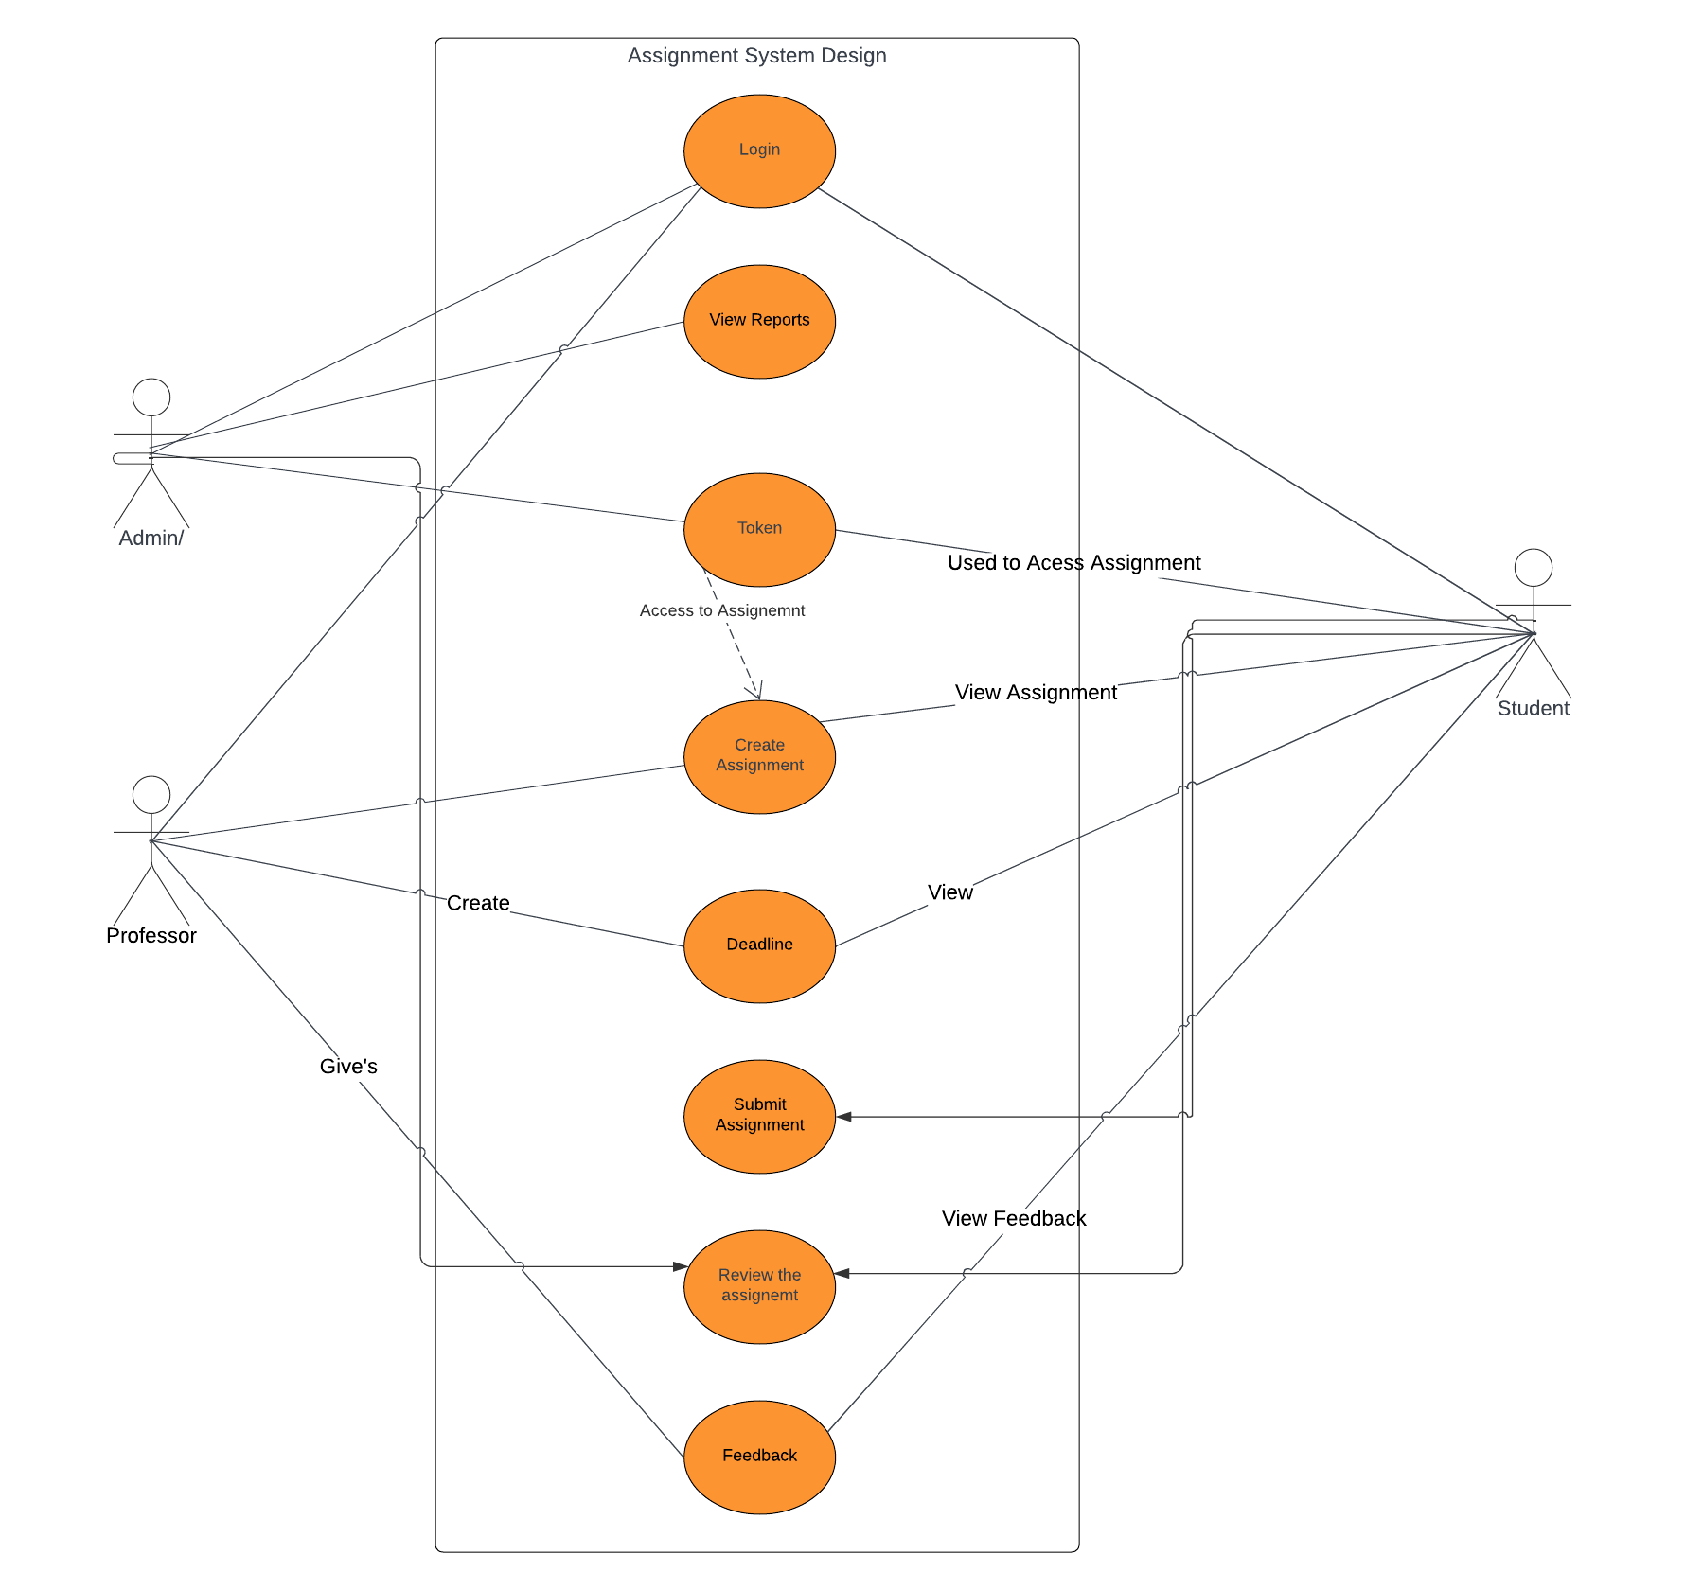

**Use Case Diagram Processes**

1. **Login:** Login Process for Admin, Professor, and Student.
2. **View Reports:** Process for Admin to generate reports.
3. **Token:** Token will be generated by the Professor while creating the assignment. This token will be used by the Admin and Student to search for Assignments.
4. **Create Assignment:** This Process will be used by Professor to create Assignments.
5. **Deadline:** This Process is used to track if the submission by student is after deadline or not.
6. **Submit Assignment:** Students will access this process to submit the assignment to the system.
7. **Review Assignment:** Professor can review the assignments submitted by the student in previous process.
8. **Feedback:** Finally feedback is the overall process which is combination of Reviewing the assignment by Professor, and viewing the grades by the student.

**C. Major Processes, Decision Tables, and Decision Tree**

**Explanation of Major Processes**

1. **Assignment Submission Process:**

Overview:

The Assignment Submission Process involves students submitting their completed assignments through the AIM system.

Steps:

Access Assignment Details using Token Value

* Students log in and navigate to the assignment section.
* View available assignments, including details like title, description, and due date.

Upload Files

* Upload the necessary file for the assignment.

Review the Submission

* Review the submission to check if submission is Graded.

1. **Register Process:**

Overview:

The Register Process involves users (students, professors) creating accounts within the AIM system.

Steps:

* Access Registration Page:
* Users navigate to the registration page.
* Provide User Details:
* Enter necessary information like username, password, email, etc.
* Submit Registration:
* Registration page, user details entry, registration submission, confirmation.

1. **Report Generation Process:**

Overview:

The Report Generation Process involves administrators generating performance reports based on system data.

Steps:

* Access Reporting Module:
* Administrators log in and access the reporting module.
* Specify Report Criteria:
* Generate Report:
* View Report

1. **Assignment Creation Process:**

Overview:

The Assignment Creation Process involves professors creating and posting new assignments for students.

Steps:

* Access Assignment Creation Interface:
* Professors log in and navigate to the assignment creation interface.
* Enter Assignment Details:
* Enter assignment details, including title, description, due date, and attached resources.
* Submit Assignment:

1. **Assignment Review Process:**

Overview:

The Assignment Review Process involves students reviewing feedback and grades provided by professors.

Steps:

* Access Graded Assignments:
* Students log in and access a list of their graded assignments.
* Review Feedback and Grades:
* View the feedback and grades provided by professors.

**Decision Tables**

1. **Assignment Submission Process**

|  |  |
| --- | --- |
| **Conditions** | **Actions** |
| Student is Logged In | Display Assignment Details |
| Assignment Due Date Passed | Show Late Submission in Red |
| Assignment Selected | Enable File Upload |
| Submission Confirmed | Acknowledge Submission |
|  |  |
| Results/Outcomes | Actions |
|  | Submit Assignment to System |

1. **Register Process**

|  |  |
| --- | --- |
| **Conditions** | **Actions** |
| User Type | Display Registration Form |
| User Submits Form | Validate and Process Registration |
| Registration Success | Send Confirmation Email |
|  |  |
| Results/Outcomes | Actions |
|  | Create User Account in the System |
|  | Assign User Role (Student/Professor/Admin) |

1. **Report Generation Process**

|  |  |
| --- | --- |
| **Conditions** | **Actions** |
| User is Administrator | Access Reporting Module |
| Specify Report Criteria | Generate Report |
|  |  |
| Results/Outcomes | Actions |
|  | View and Analyze Generated Report |

1. **Assignment Creation Process**

|  |  |
| --- | --- |
| **Conditions** | **Actions** |
| User is Professor | Access Assignment Creation Interface |
| Professor Enters Assignment | Submit Assignment to System |
| Title and Description Valid | Display Confirmation Message |
|  |  |
| Results/Outcomes | Actions |
|  | Create Assignment in the System |
|  | Display Confirmation Message |

1. **Assignment Review Process**

|  |  |
| --- | --- |
| **Conditions** | **Actions** |
| User is Student | Access Graded Assignments |
| Graded Assignment Available | Review Assignment Feedback and Grades |
|  |  |
| Results/Outcomes | Actions |
|  | View and Analyze Assignment Feedback and Grades |

**Decision Trees**

1. **Assignment Submission Process**

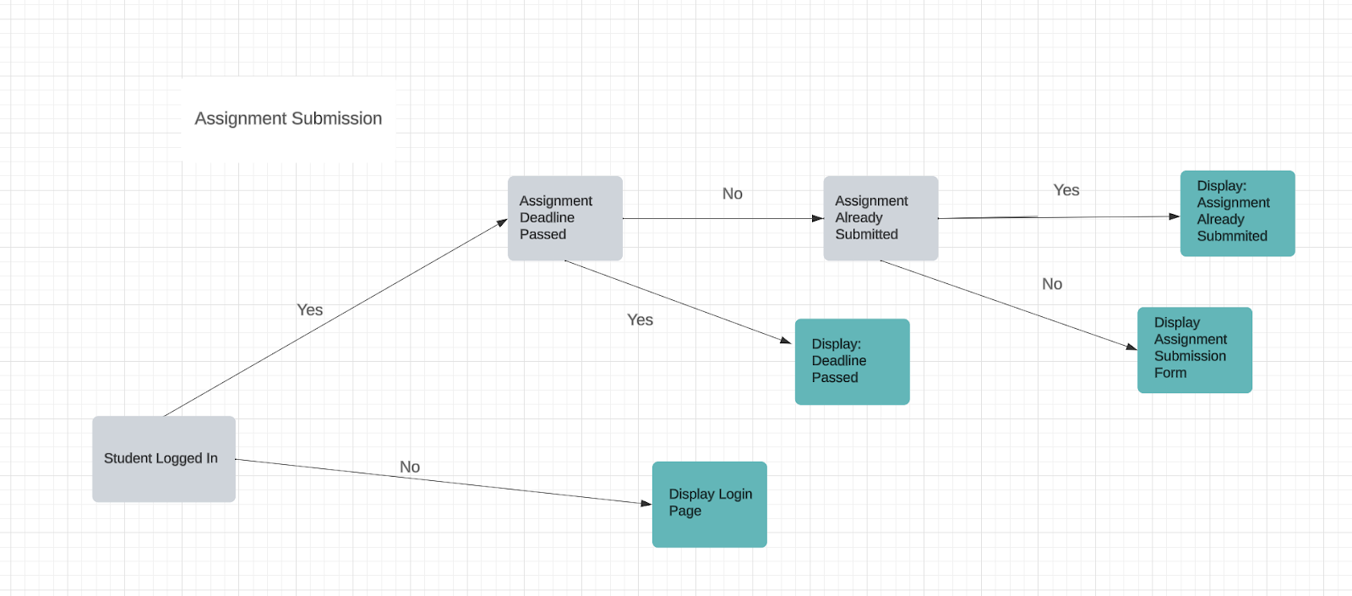

1. **Register Process**

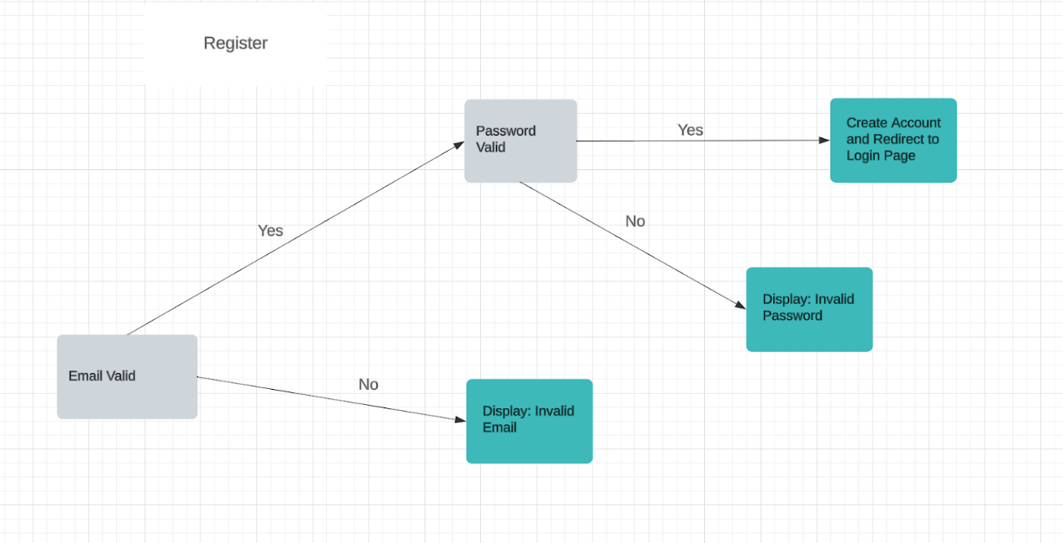

1. **Report Generation Process**

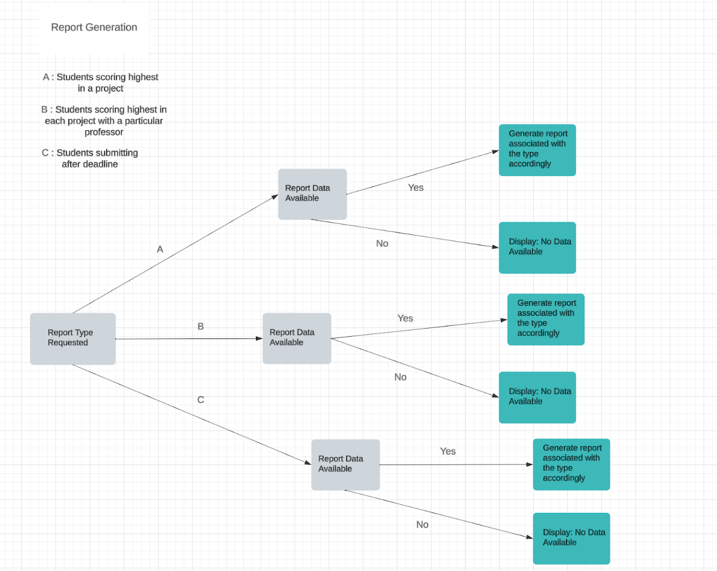

1. **Assignment Creation Process**

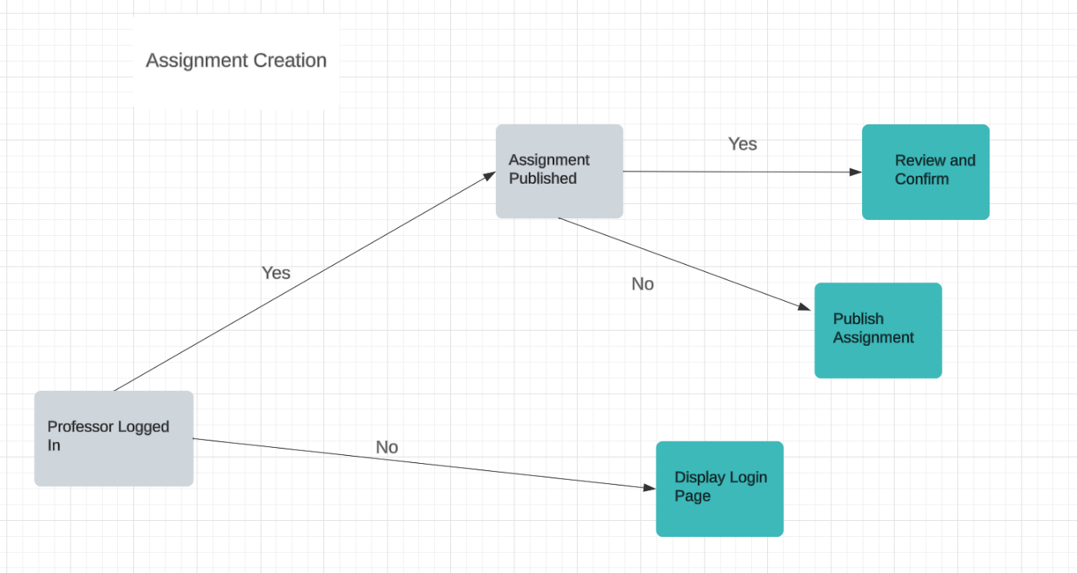

1. **Assignment Review Process**

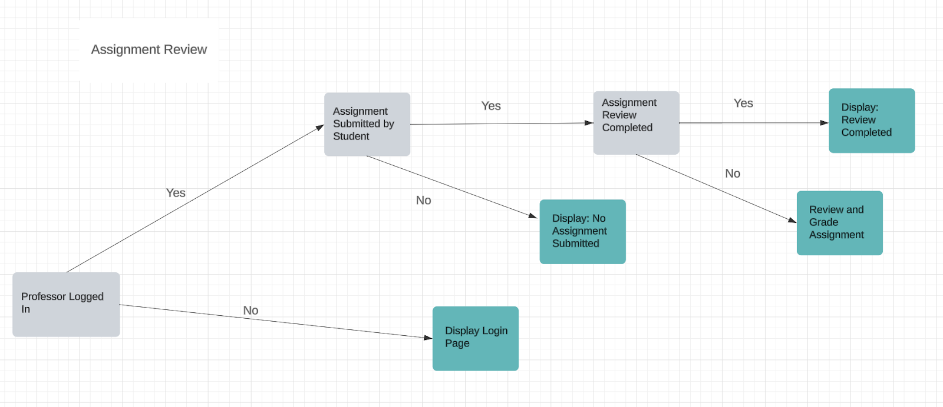

**D. Database Design and Schema Diagrams**

The Assignment Information Management System (AIM) utilizes MongoDB as its database management system, offering a flexible and scalable solution for storing and retrieving data related to assignments, submissions, user profiles, and analytics.

**Database:** MongoDB

**Relationships**: MongoDB is a NoSQL Database, So we did not define any specific relationships between different database fields.

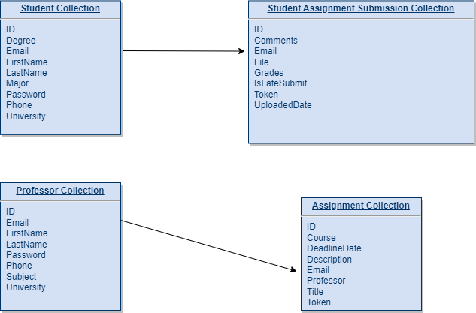

**Collections (Sample Document in Each Collection)**

1. **Student Collection**

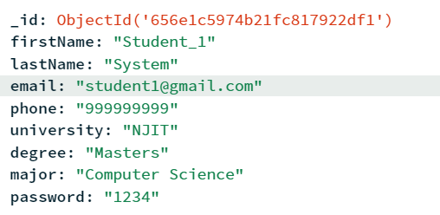

1. **Professor Collection**

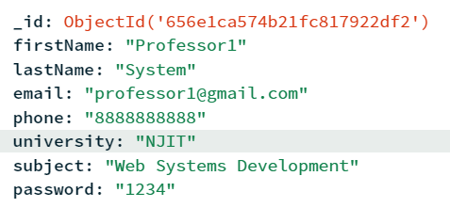

1. **Assignment Collection**

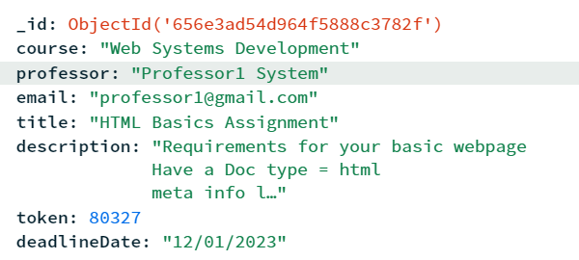

1. **Student Assignment Submission Collection**

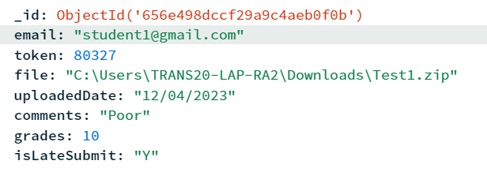

**Phase IV**

**A. Demo PPT**

https://docs.google.com/presentation/d/12kQTQw56XMlZTCSNZaDJqXURi8or0OMt0McwZF92Qz8/edit#slide=id.gcb9a0b074_1_0

**B. Applications Screenshots**

* Professor Registration

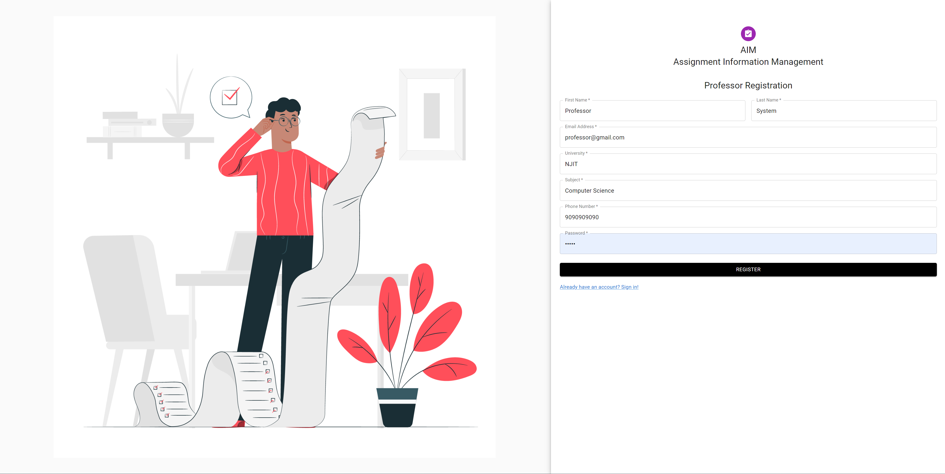

* Login

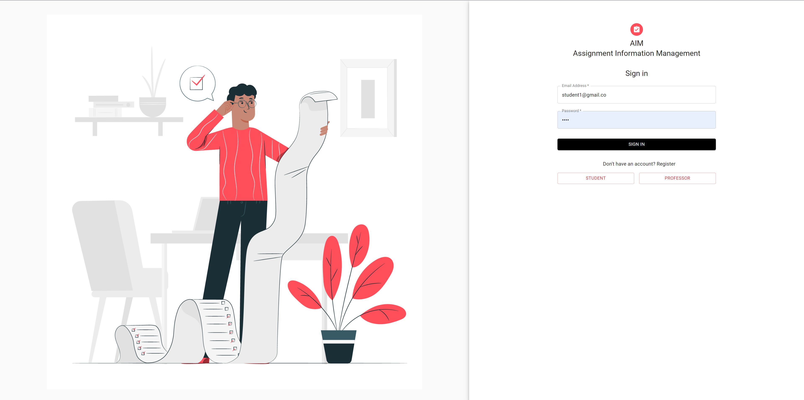

* Professor Profile View

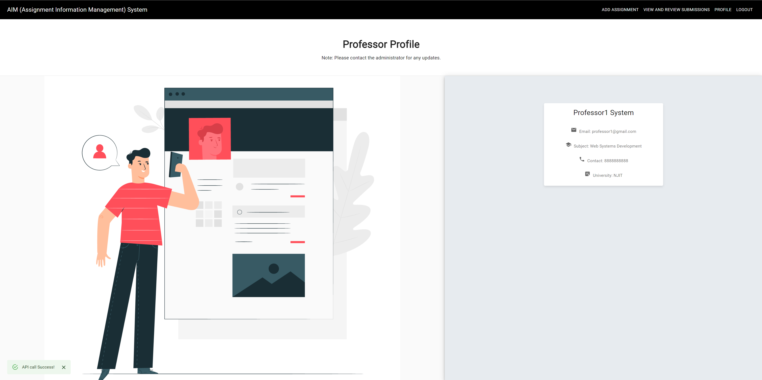

* Assignment Creation

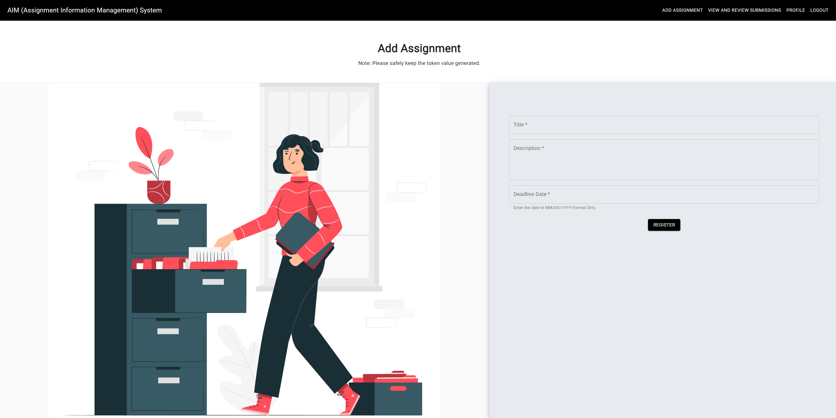

* Student Registration

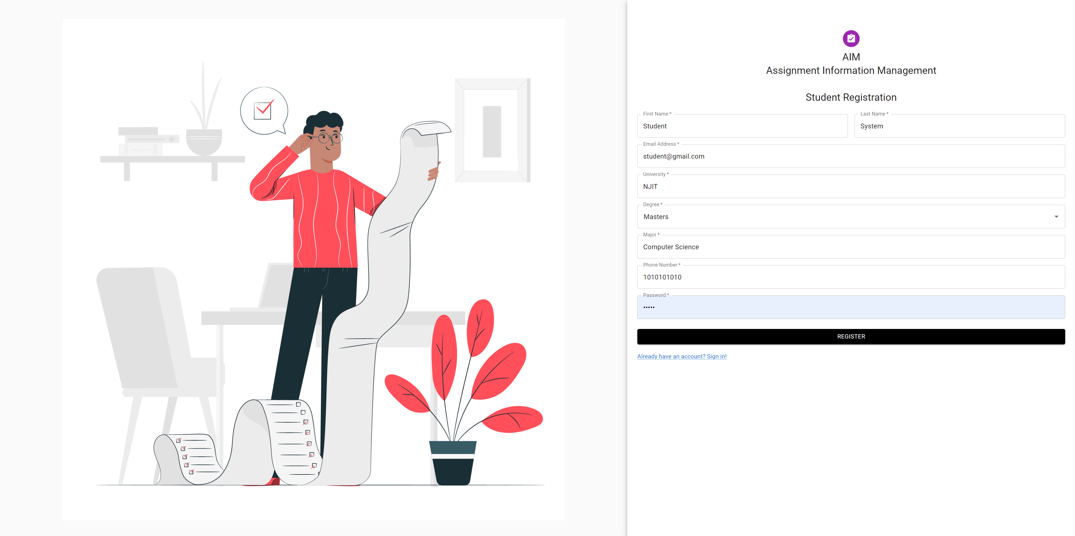

* Student Profile View

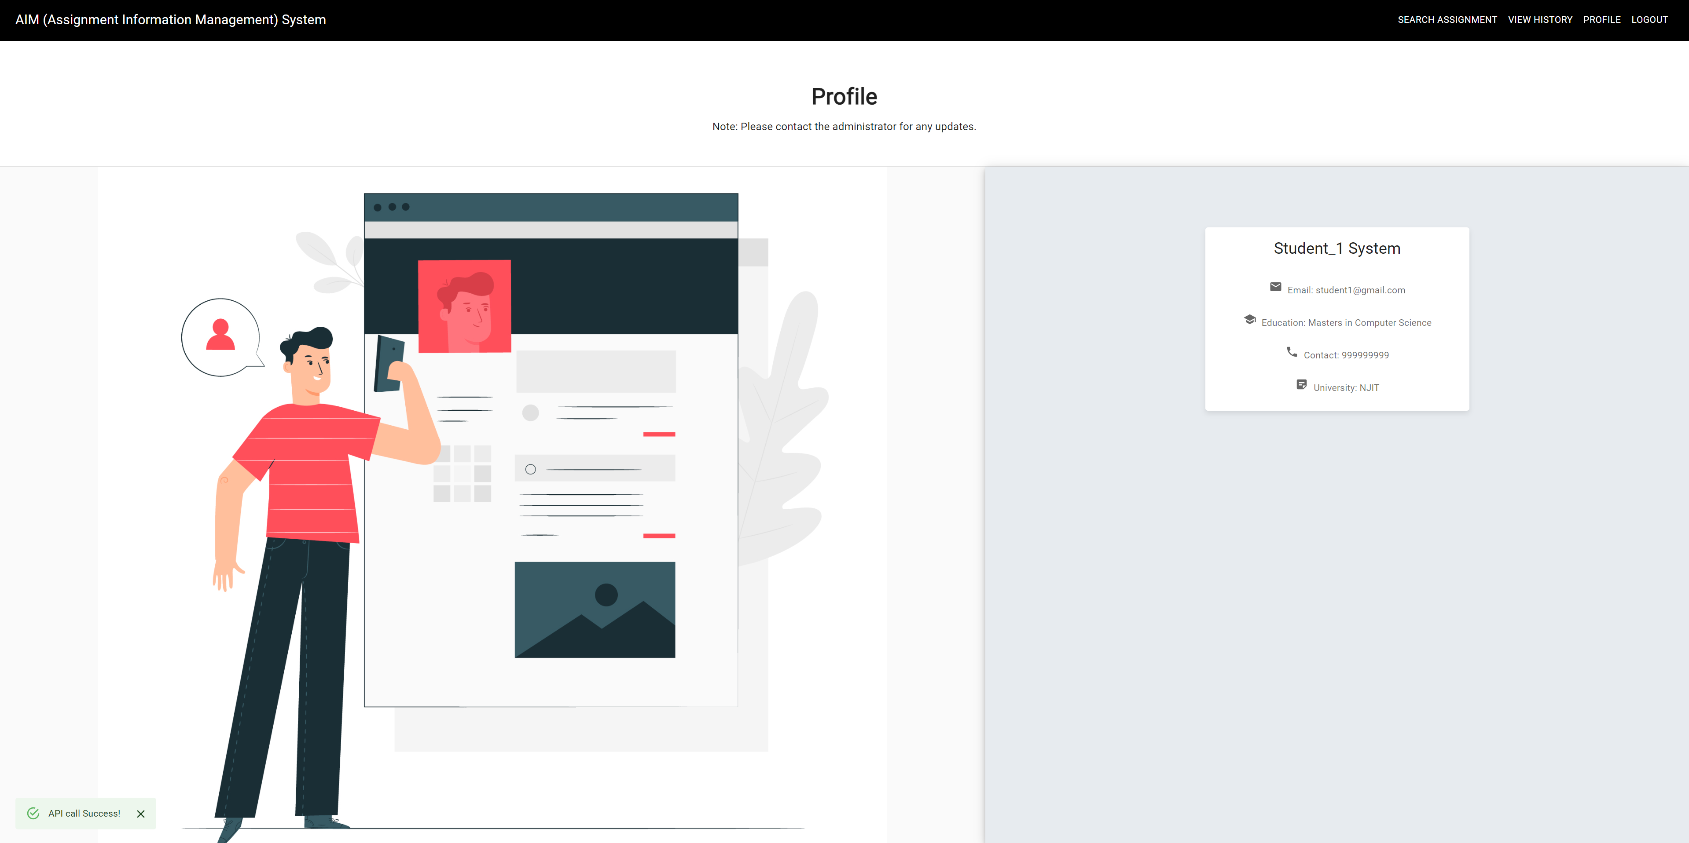

* Assignment Submission View

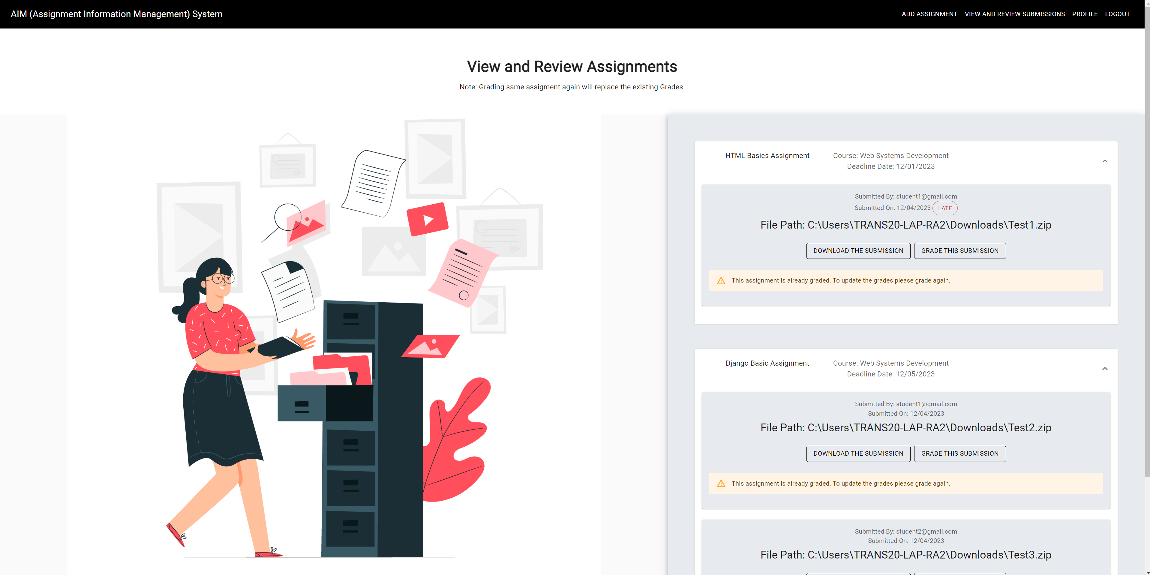

* Assignment Grading

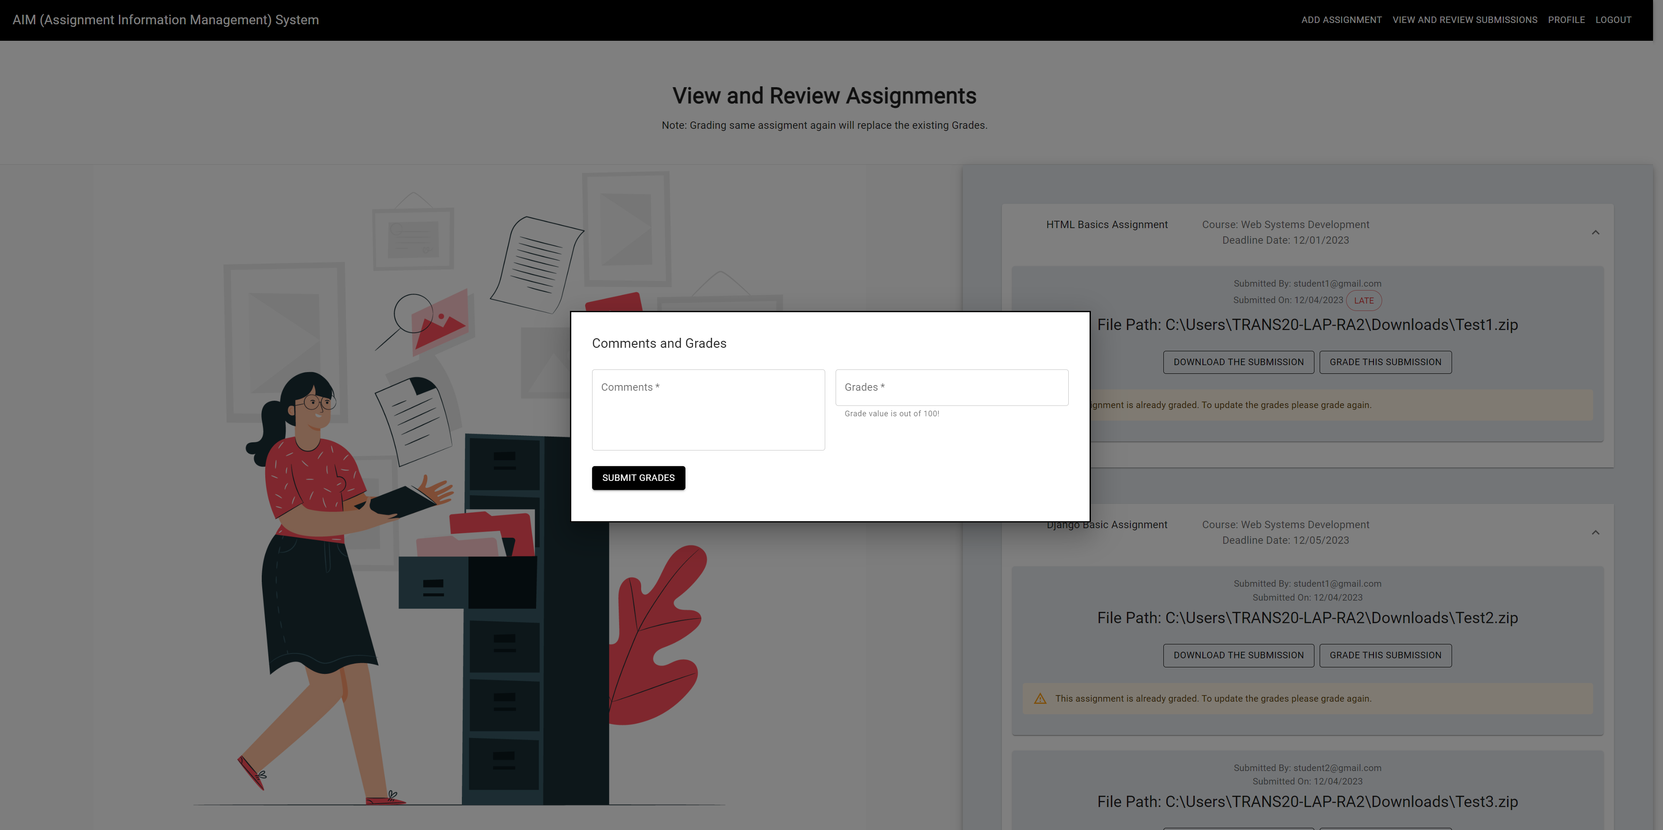

* View Reports

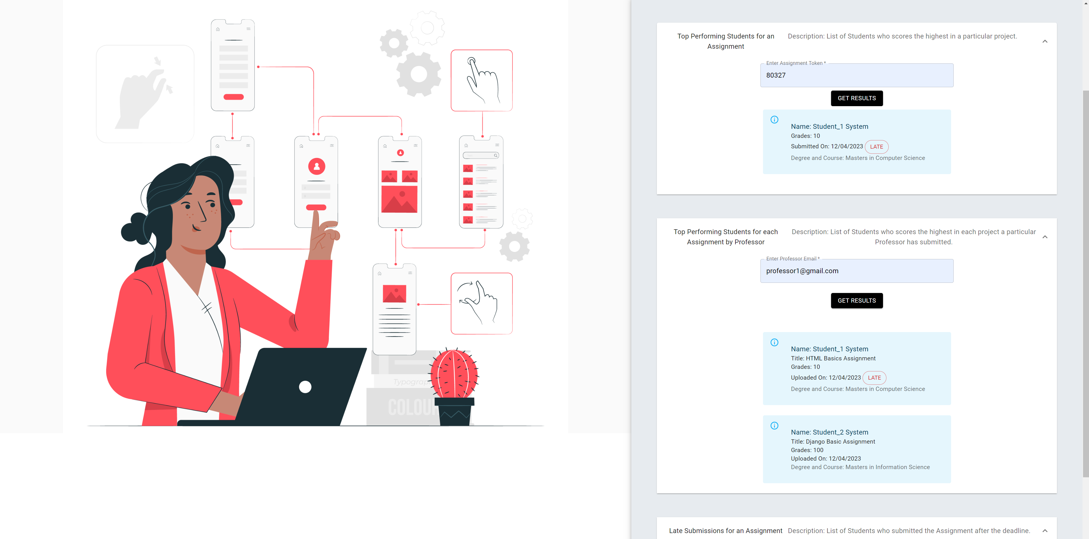

**C. Navigation around the Application**

Professor Menu

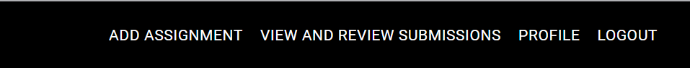

Student Menu



**D. User Input Transactions**

Sample Registration Form which calls the Backend API to store Data in DB

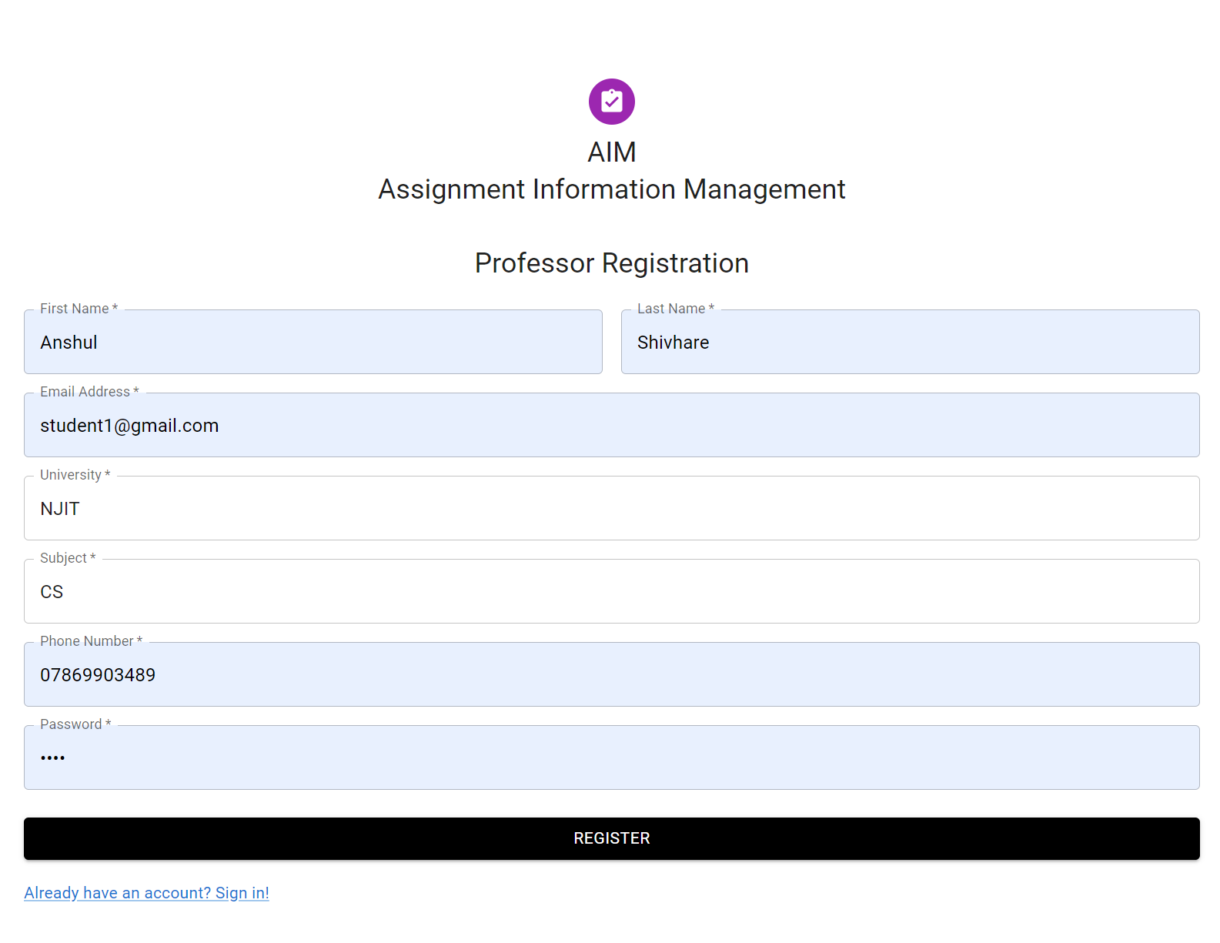

**E. Modifying the Submitted Assignment**

API will check if the searched assignment submission already exists. On re-uploading the Content, the content will get overridden. This will modify the existing Data.

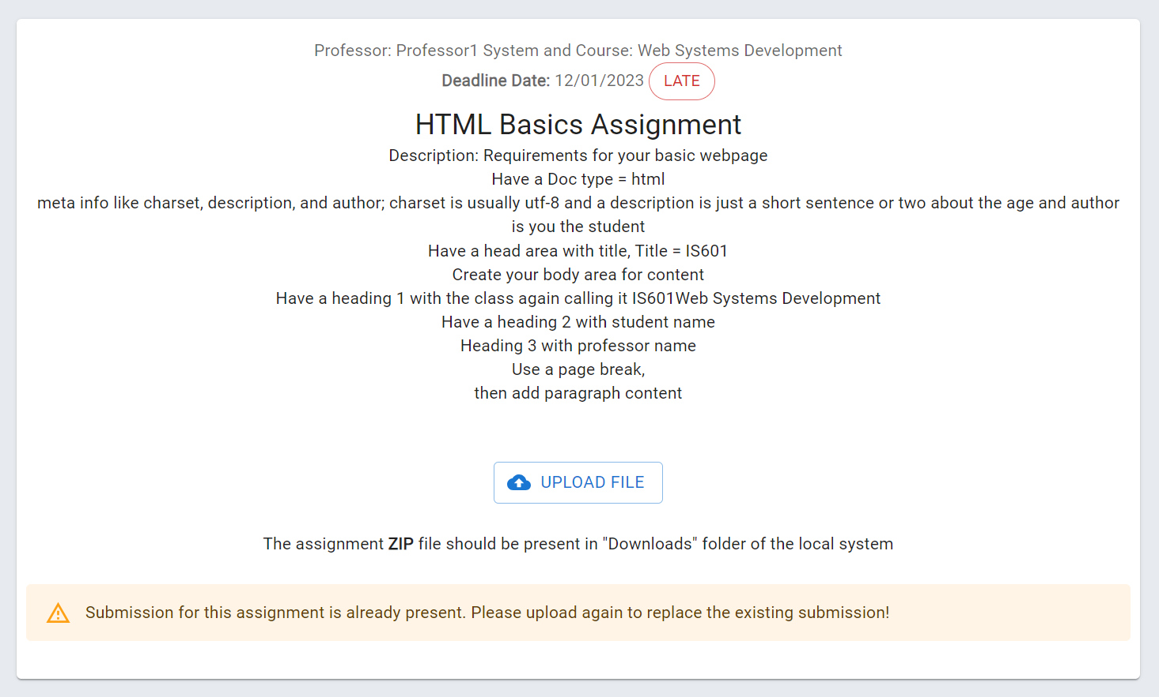

**F. Report Results**

Sample Report Results

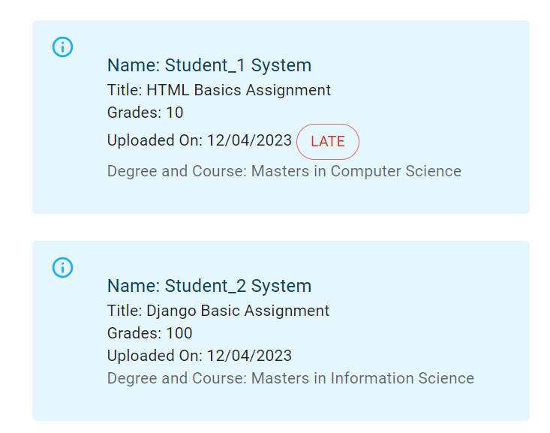

**Phase V**

**A. Architecture Diagram**

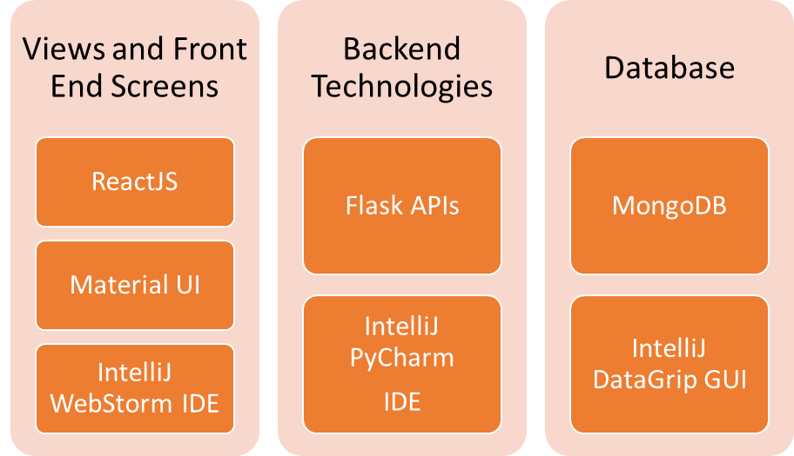

**Options**

* **Front End:** ReactJS, AngularJS.
* **Back End:** Flask, Django
* **DB:** MySQL, MongoDB

**Decision Reasons**

* **ReactJS:** Ease of Use and Team’s Experience with React
* **Material UI:** Material UI allowed us to design our application with beautiful reusable components in a short time.
* **Flask APIs:** Since the scope of application was not big enough, we chose Flask to create simple APIs to communicate with MongoDB Backend.
* **MongoDB**: Mongo being NoSQL DB allowed us to easily integrate it with our application.
* **IntelliJ Toolkit:** IntelliJ provided us with three IDEs that we used to develop the application.
  + WebStorm -> For ReactJS Development
  + PyCharm -> For Flask Development
  + DataGrip -> For MongoDB Console Queries

**B. Application Testing**

**Testing Key Features**

**1.** **User Authentication:**

**Scenario**: Verified that users (students, professors, and administrators) can log in with valid credentials and are denied access with incorrect credentials.

**Potential Bugs**: Incorrect login credentials not triggering appropriate error messages, session management issues, or security vulnerabilities.

**2. Assignment Creation and Posting:**

**Scenario**: Tested the creation and posting of assignments by professors, ensuring all details (due dates, descriptions, resources) are accurately saved and displayed.

**Potential Bugs**: Assignment details not saving correctly, incorrect display of assignment information, or issues with due date calculations.

**3. Assignment Submission:**

**Scenario**: Tested the submission process for students, ensuring they can upload files, receive confirmation, and view their submission history.

**Potential Bugs**: File upload failures, incorrect confirmation messages, or errors in tracking and displaying submission history.

**4. Grading and Feedback:**

**Scenario**: Tested the grading process for professors, ensuring they can assign scores, provide feedback, and that students can view this information.

**Potential Bugs**: Grading errors, feedback not saving correctly, or discrepancies between what professors input and what students see.

**5. Usability Testing:**

**Scenario**: Evaluated the overall user experience by observing how easily users navigate the system and perform common tasks.

**Potential Bugs:** User interface issues, unclear instructions, or inconsistencies in design elements affecting user experience.

**6. Cross-Browser and Cross-Device Testing:**

**Scenario**: Tested the system's compatibility with various browsers (Chrome, Firefox, Safari, etc.) and devices (desktops, tablets, mobile phones).

**Potential Bugs**: Display issues, functionality discrepancies, or performance variations across different browsers and devices.

**Bugs Encountered**

1. **Email Textbox Issue**

**Issue**: Emails without “@” were allowed on Registration Page

**Fix**: Added MUI Check to only allow Valid Email IDs.

1. **Deadline Date Comparison Issue**

**Issue:** Assignments submitted after the deadline were not showing as “Late” Submissions due to dates not being in proper format

**Fix:** Fixed the Date format across the whole application to be fixed as “MM/DD/YYYY”

1. **Token Value Search Issue**

**Issue:** After creating the assignment, the user was not able to search this assignment using the token value.

**Fix:** We Converted the token value to always be an Integer.

**Some other common issues that were encountered are as below**

* “\n” Character not being rendered properly.
* The results of projects were not getting cleared on changing the page.
* Admin Console Image alignment Issue.
* Fixing Button Colors to match with the overall theme.

**C. Application Training**

Training is a crucial aspect of implementing the AIM System to ensure that users (students, professors, and administrators) are proficient in using the platform effectively. The training plan will be comprehensive, covering different aspects of the system. Here's how we would roll out the training.

**1. Training Audience**

**Students**: Focus on assignment submission, profile management, and understanding performance analytics.

**Professors**: Cover assignment creation, grading, reviewing student performance, and effective utilization of communication features.

**Administrators**: Include user management, system customization, and data analytics.

**2. Training Duration:**

**Students**: A concise 1 to 2-hour session, covering essential features like assignment submission and profile management.

**Professors**: A more in-depth 2 to 3-hour training, encompassing assignment creation, grading, and effective use of analytics tools.

**Administrators**: A comprehensive 3 to 4-hour training, focusing on user management, system customization, and advanced data analytics.

**3. Training Methods:**

**Online Tutorials**: Develop interactive tutorials for self-paced learning, offering accessibility to users at their convenience.

**Live Webinars**: Conduct live webinars tailored for each user group, allowing for real-time interaction and Q&A sessions.

**Documentation**: Provide detailed user manuals and documentation as a reference for continuous learning.

**4. Key Training Topics**:

**For Students:**

**Assignment Submission**: Step-by-step guidance on submitting assignments, attaching files, and confirming submissions.

**For Professors:**

**Assignment Creation:** Detailed walkthrough on creating assignments, setting due dates, and attaching necessary resources.

**Grading and Feedback:** In-depth training on the grading interface, providing constructive feedback, and leveraging student profiles for performance tracking.

**5. Post-Training Assessments:**

Conduct assessments after training sessions to evaluate user comprehension and identify any areas that may need additional clarification.

Leverage feedback from post-training assessments to refine training materials and address any remaining user concerns.

By tailoring the training plan to the specific needs of each user group and employing various learning methods, our goal is to empower all AIM users to navigate the platform confidently and derive maximum benefit from its features.

**D. Implementation Plan**

**Deployment Stack**: We plan to use the below cloud services to deploy the application for our users.

AWS Services

Amazon EC2

Amazon MongoDB Atlas

AWS CloudFront

AWS IAM

**Rollout Phases**

**Phase 1: Internal Testing (2 weeks)**

Conduct thorough testing of AIM with a small group of internal users.

Identify and address any critical issues or bugs.

Gather feedback for further improvements.

**Phase 2: Pilot Rollout to Select Users (4 weeks)**

Launch AIM for a limited group of users, such as a specific department or class.

Monitor system performance, user feedback, and any additional issues.

Make necessary adjustments based on user experience.

**Phase 3: Full Deployment (6 weeks)**

Gradually expand access to AIM for all students, professors, and administrators.

Provide additional support and training resources.

Monitor system performance and address any emerging issues promptly

**Agile Workflow**

We plan to work in an Agile fashion to rapidly fix the issues and move on to deployment. Below is a typical agile workflow that we will follow.

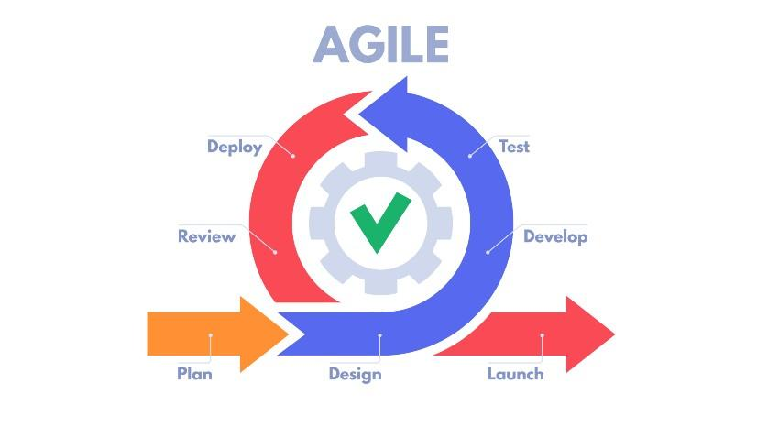

**E. Support Plan**

The post-launch and support phase is crucial for maintaining the functionality, user satisfaction, and continuous improvement of AIM.

Below is our plan for providing continuous support to our users.

**1. Support Team:**

Establish a dedicated support team responsible for addressing user inquiries, issues, and providing assistance.

Ensure the support team is well-versed in AIM's features and functionality.

**2. Support Channels:**

**Helpdesk System**: Implement a helpdesk or ticketing system for users to submit inquiries and issues. This ensures a systematic approach to problem resolution.

**Email Support**: Provide an email support channel for users who prefer this mode of communication.

**3. User Documentation:**

Develop and regularly update comprehensive user documentation, including manuals, FAQs, and troubleshooting guides.

Make documentation easily accessible within AIM for quick reference.

**4. Training Resources:**

Maintain a repository of training resources, including recorded webinars, tutorials, and guides, for new and existing users.

**5. Continuous Improvement:**

Regularly collect user feedback to identify areas for improvement and address emerging issues promptly.

Implement periodic updates and enhancements based on user suggestions and technological advancements.

**6. User Forums or Community:**

Create user forums or a community space where users can interact, share experiences, and seek advice from peers.

Foster a collaborative environment for users to help each other.

**7. Version Release Notes:**

Publish release notes for each version, detailing the changes, enhancements, and bug fixes implemented.

Keep users informed about the benefits and improvements with each update.

By implementing a comprehensive post-launch and support plan, AIM aims to provide users with the necessary resources, assistance, and avenues for continuous improvement. Regular communication, user feedback, and a proactive approach to issue resolution are key components of this plan.

**F. Future Modifications**

As AIM continues to evolve, future modifications and additional features will be essential to meet the changing needs of users and educational institutions. Here's a overview of the potential enhancements and modifications planned for AIM.

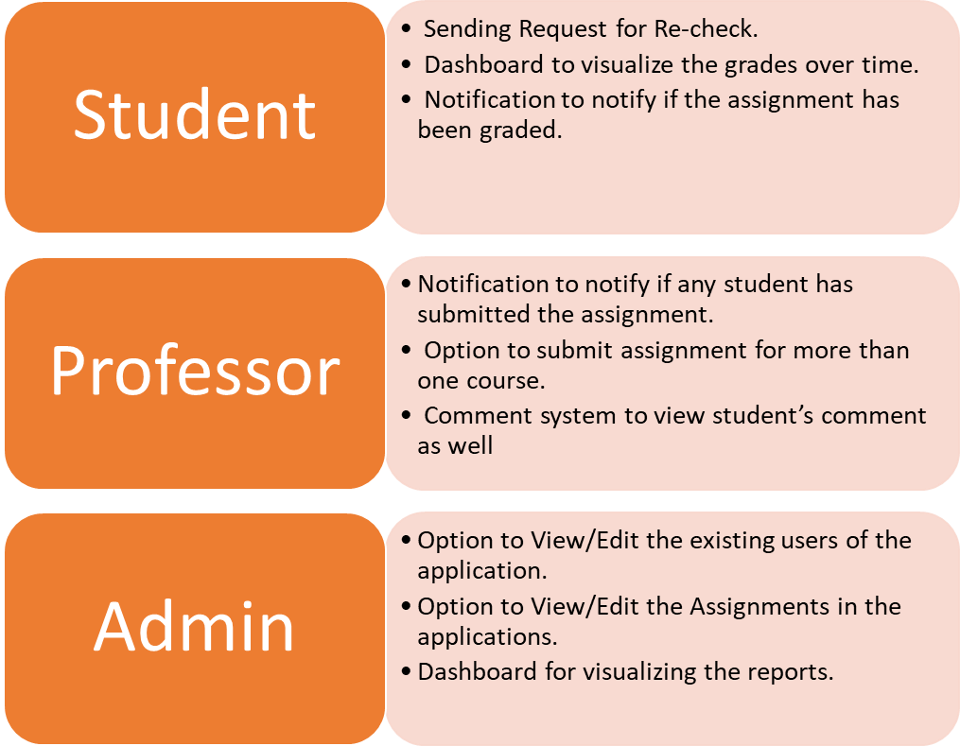

**Appendix**

**A. Project Approval Form**

**Drive Link**

<https://drive.google.com/file/d/1bO461ci6PKHaKZgqUIjCRFBXC4-l-dxr/view?usp=sharing>

**B. Gantt Chart**

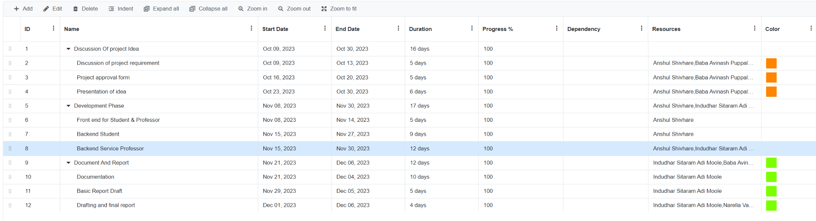

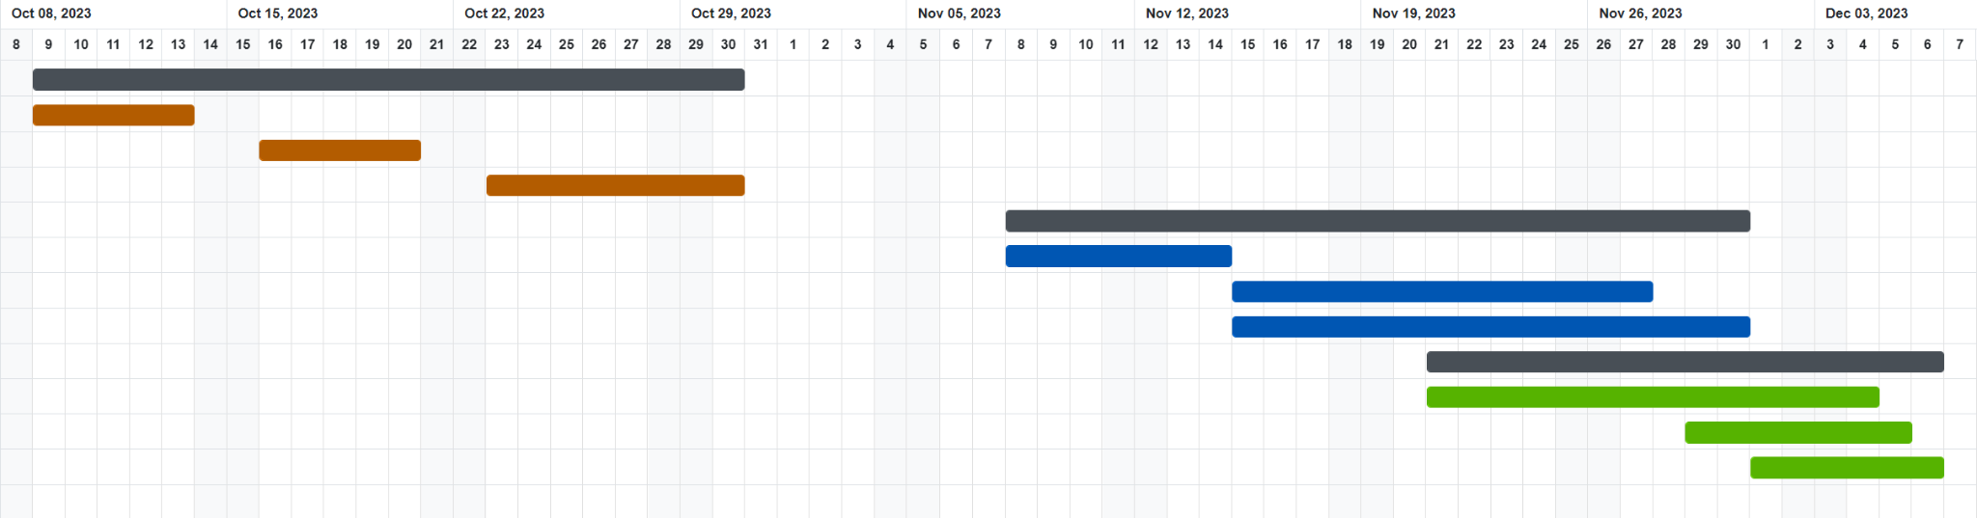

**PDF Link**

https://drive.google.com/file/d/1SFQ4bcUT1PNhe7S3_ln1Kg7u4DySHTFR/view?usp=sharing

**C. Meeting Logs**

**Meeting Log 1**

**Date**: 09/26/2023

**Attendees**: [Anshul, Baba, Indudhar, Karan, Vamshi]

**Agenda**: Project Startup

* Introduction to the AIM project.
* Understanding the roles and responsibilities of team members.
* Overview of project objectives and key deliverables.
* Discussion on the significance of AIM in academic institutions.

**Action Items**:

* Assign roles to team members (Student, Professor, Administrator).
* Research on best practices for assignment management systems.
* Define specific features for each role

**Meeting Log 2**

**Date**:10/03/2023

**Attendees**: [Anshul, Baba, Indudhar, Karan, Vamshi]

**Agenda**: Feature Planning for Student Role

* Discuss features for Student role: Profile Management, Assignment Submission, Submission History.
* Clarify file restrictions for assignment submissions(such as submission of only files of particular format).
* Brainstorm ideas for a user-friendly interface.

**Action Items**:

* Create the UI for Student interface.
* Define the structure of the submission history database.
* Research secure file handling practices.

**Meeting Log 3**

**Date**: 10/12/2023

**Attendees**:[Anshul, Baba, Indudhar, Karan, Vamshi]

**Agenda**: Feature Planning for Professor Role

* Discuss features for Professor role: Assignment Posting, Assignment Management, Grading and Feedback.
* Define the elements of the assignment dashboard.
* Discuss options for providing feedback within the platform.

**Action Items**:

* Create UI for Professor interface.
* Plan database schema for assignments and submissions.
* Research effective grading mechanisms.

**Meeting Log 4**

**Date**: 10/24/2023

**Attendees**: [Anshul, Baba, Indudhar, Karan, Vamshi]

**Agenda**: Feature Planning for Administrator Role

* Discuss features for Administrator role: User Management, Reports Generation.
* Define access control mechanisms.
* Specify details for each report generation functionality.

**Action Items**:

* Create similarity for Administrator and Professor interface.
* Plan database schema for user management.
* Research reporting tools and frameworks.

**Meeting Log 5**

**Date**: 11/02/2023

**Attendees**:[Anshul, Baba, Indudhar, Karan, Vamshi]

**Agenda**: Project Progress and Challenges

* Review progress on individual features.
* Discuss challenges faced by team members.
* Brainstorm solutions and adjustments to the project plan.

**Action Items**:

* Address any roadblocks faced by team members.
* Adjust timelines if necessary.
* Continue with development and testing.

**Meeting Log 6**

**Date**: 11/30/2023

**Attendees**: [Anshul, Baba, Indudhar, Karan, Vamshi]

**Agenda**: Testing

* Discuss testing strategies for each role.
* Ensure cross-role compatibility and data integrity.

**Action Items**:

* Develop test cases for each role.
* Assign team members for Testing.
* Conduct rigorous testing before deployment/demo.

**Meeting Log 7**

**Date**: 12/05/2023

**Attendees**: [Anshul, Baba, Indudhar, Karan, Vamshi]

**Agenda**: Final Review and Documentation

* Review the complete system.
* Document any last-minute changes or adjustments.
* Prepare for the project presentation and report.

**Action Items**:

* Finalize documentation for each role.
* Create a presentation highlighting key features.
* Rehearse for the project presentation/demo.

**D. Variance Report**

|  |  |  |
| --- | --- | --- |
| **Title** | **Original Scope** | **Variance** |
| Admin Reports | We planned for 5 Different types of Reports as below.  Top Performing Students Reports  Under Same Assignment  Under Same Professor Across Assignments  Across whole Application  Late Submissions Reports  By Assignment Level  By Application-Level Report of all Late Submissions | We skipped 2 reports from planned since we did not find any analytics relevance of these.  Skipped Reports  1. Top Performing Student Across Application  2. Late Submissions at Application Level |
| Assignment Notification | We planned to have a notification system. So as soon as Student has submitted an assignment, the Professor will be notified. | We skipped notification to reduce the complexity of the application. We do not have a notification system in place. Instead, Professor have view assignment submission module to view submissions |
| Profile Management | We planned to have an edit option in the profile module. So that user can modify their profile details | We were not able to add this option due to time constraints. We added this feature as part of future implementation |
| Student Comments on Submission | We planned to give an option to students to add comments with the file upload. | We were not able to add this option due to time constraints. We added this feature as part of future implementation |